**RESTFUL API**

Heard in web world a lot

Now someone might have a web server with web data in it

My mbile phone will be a sending a request to that webserver

API🡪which will connect me and that server

Now how will we know what services does erver provide ?

And how does server know me ?

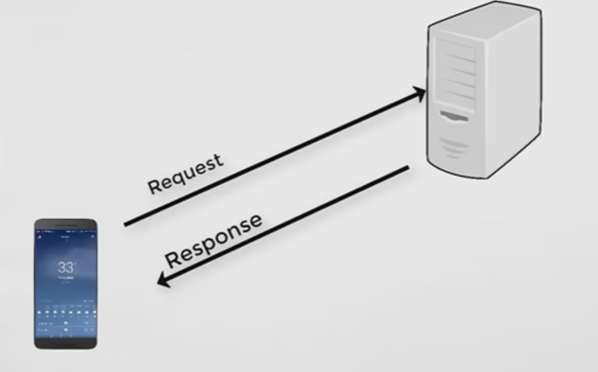

So now coming to server ,we will create a servlet in Java world and client will send a request

And now servlet will give you a response

Whatever it is server will give back you a webpage

Browser is a blank page ..it will parse the data received from the server

Data types from server:

1.XML :Heirachial structure

XML is bulky also

2.JSON:Key Value based structure

Servelet returns either one

Servlet actually creates lot of overhead a bulky thing

To replace this is actually using RestApi

Means basically we send the state of the object in JSON format -what we send is not the object but the state of the object –Represetational State transfer

What ever is web technology we always do **CRUD** operation-Create ,replace ,update ,delete

We are actually fetching the resource back

C ->Create -> Post

R -> Read -> Get

U -> Update-> PUT

D -> Delete -> Delete

Using these 4 methods of HTTP we would be achieving the crud operation

How can we implement the REST?We have many ways but the

Famous is Jersey , Spring implementation of Rest

Rest is just a concept but to implement we use jersey or spring

Prerequisite is Maven knowledge bcz using it we create the base Project structure

POJO-Plain Old Java Object

Tools:Eclipse

Note:We need Eclipse Java EE as we need to add the servers

Make sure tomcat is available on your machine if not download the same form google and save it on your machine

Another prerequisite is Maven

Maven is a build tool

Lets say we want to build a project ,we want something which will give all libraries ,testing assets ,compilers etc etc

When we work with spring ang struts we need few libraries we do all these from spring.io

Lets say today we downloaded spring 5 version libraries and later spring 6 came again we need to download all of them

What if somewhere in the project we can just mention that I need spring libraries and later the files get downloaded automatically ..!!?? Yes using the Maven we can achieve that

For this first we need to create a Maven Application

Generally whenever we create a project we create a Java project but now lets first learn maven Project

File ->New Maven Project ->Arch type will be chosen depending upon the application we are going to build

Maven is a network ready framework ,depending upon the arch type we chose immediately it will download all the necessary resources

And now for our application …

Group id is my package name

Artifact id is Project name

GroupID +project id is package

When we click on finish it will create a project

And now in maven dependencies we can see the jar files

When we create a fresh new project it will fetch from remote repos or else it will fetch from local

Main part of maven is pom.xml 🡪It contains all the configuration

We don’t write anything it will everything automatically

In POM .xml if it is java we get packaging as jar ,if it is web we get war

If we are using any third party items we need to give the entry in dependencies

And once we add the dependnices and paste it in the pom.xml ,all the required jar files will be fetched from the remote repo and will be added it to the project

Coming back to our **Jersey** Creation …

Maven Project 🡪Select the arch type as Jersey Quick start WebApp -🡪Click on Finish

It looks like below

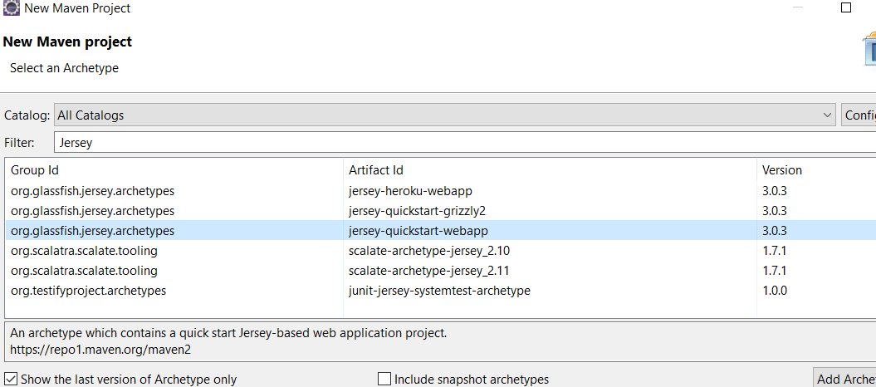

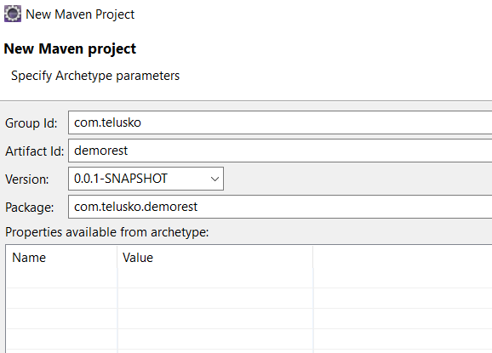

Note :

1.Sometime s required arch types might not come up, in that case maven is not able to interact with the internet

Prefrences 🡪Maven –->Enable the download arch type basically the below 4 options

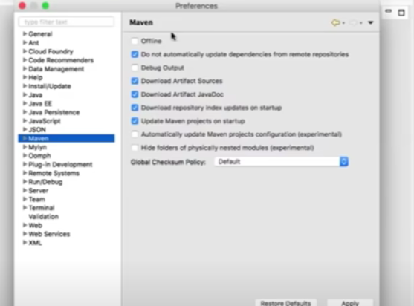

2.Somtime you will also get a error “I have get a problem when I create a new web project in the eclipse.”

Whenever we create a web project ,make sure the Apache tom cat server has been assigned to it or any webserver assigned to it .

For this steps are …

1. right Click on the Project properties.
2. In the Left menu, we can see the Java Build Path
3. Select the Library tab, and add the new Library.
4. In the Library Type, select the Server Run time, then click next and Finish will solve the problem.

So basically assign some web server to it

Now coming back to the project …

What we have is a simple web app project

POM.xml is the main one

All java files ike servlets ,modular files will be in the java folder

Jsp.java script pages etc will be in web resources

Now to run the application -🡪Right click the project 🡪RunAs 🡪Run On server

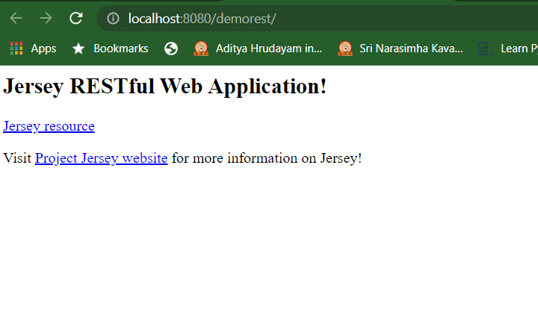

Awesome application is loaded but we get a error in colsole

SEVERE: Servlet [Jersey Web Application] in web application [/demorest] threw load() exception

java.lang.ClassNotFoundException: jakarta.servlet.Filter

For suppose if we try <http://localhost:8080/demorest/myresource> it throws error because it is not able to identify the reqeuest /rrsource

Now where are these configured ---WEbINF-🡪web.xml

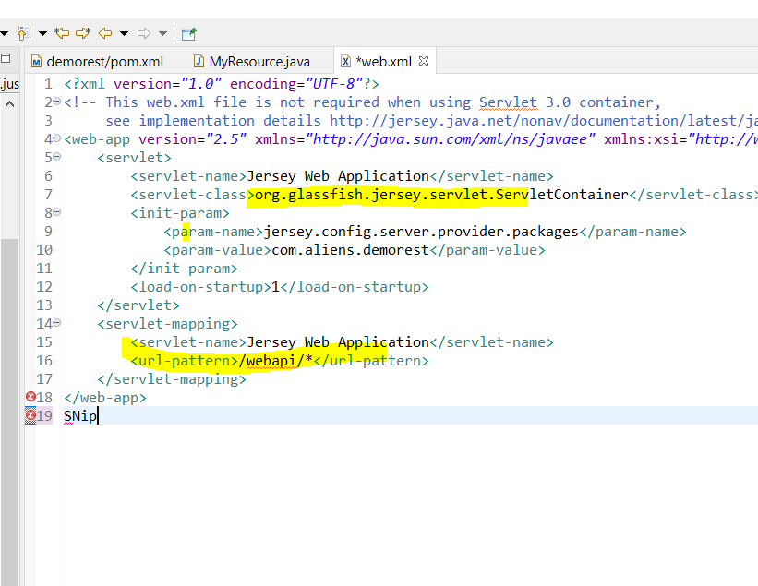

In the above pic we can see that

Servlet class is the class whcihc handles the request for Jersye Project

And it accepts only the requests that comes with /webapi

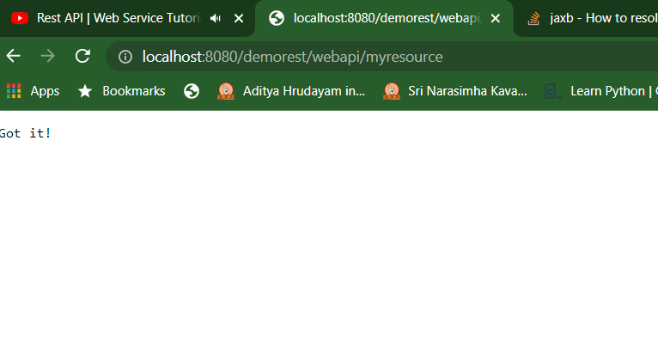

And suppose if we remove the servlet mapping from web.xml we need give the same In the url as well

Broswer 🡪URL-🡪My resource request-🡪Web.xml-🡪myservlet container-🡪takes the path 🡪which says u need to search for that path -🡪Then it goes toMyresource.java class-🡪path connected -🡪Now we have only method 🡪As of now GET request means method with get-

Above is the complete flow basically

Now we will try to create our own resource

For that first we will create object ,for that we need a class as well

Lets create a class Aline which has two attributes >add both getters and setters

This is called a simple POJO class

Now say someone requested for a Aliens… And I want to return one or multiple objects

Lets try returning one alien…and which format we send it ???JSON or XML This depends

So here when we work with spring we create controller ,there we follow mvc pattern

And here we create a own resource means a new class –Alien controller /Alien resource

Alien resource makes more sense---which return object

@Path(“aliens”)

Whenever I calls for aliens we need to call this resource

So again we need a method to work with it

So we create a method which helps to get the alien when we request

Are we done with this ..?

We shall try from the chrome by changing the url and check once post server restart

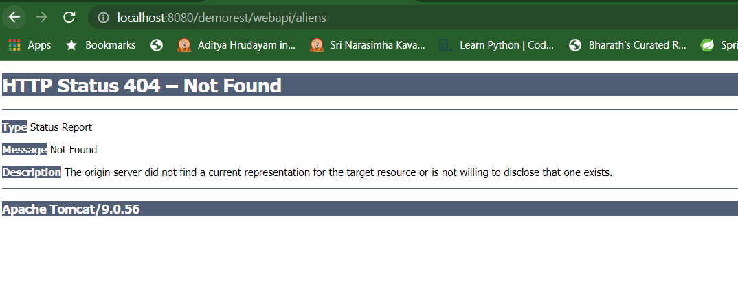

In the console

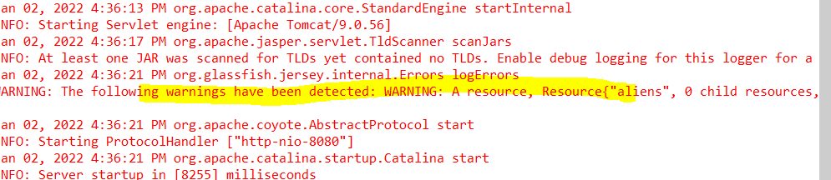

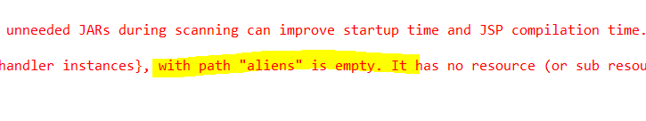

This is bcz wheevr we create resource ,we need to create a method which return something

For this we need to write @GET annotation

The @GET annotation is **a request method designator** and corresponds to the similarly named HTTP method. The Java method annotated with this request method designator will process HTTP GET requests.

Now after gving @GETannotation as below

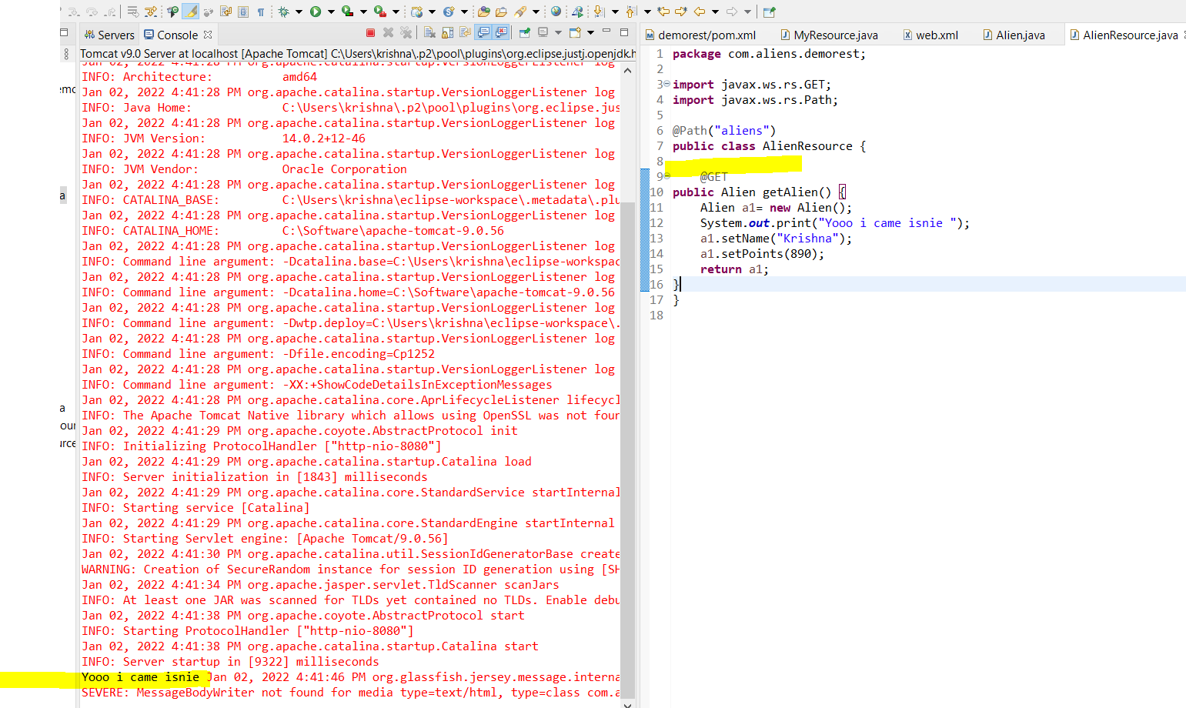

But now we are getting 500 Internal server error ,but the method id being called is seen in console

So error is Messagebody Writer not found …means we need to tell the type of the data that is beig returned

For this we would be using @ProducesAnnotation

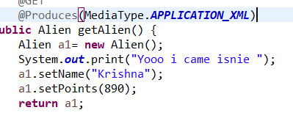

And after the context reload happened ,again we see a 500 error

Now alien is ready to get converted ,Object will returned In XML format

And now Alien should also know the root element na ….bcz XML is hierarchical structure like for example which is the root object ,which are child elements

So for this we need to write @XmlRootElement in the Alien .java class

We need to this annotation because we want to return the XML file

Done now we have the output

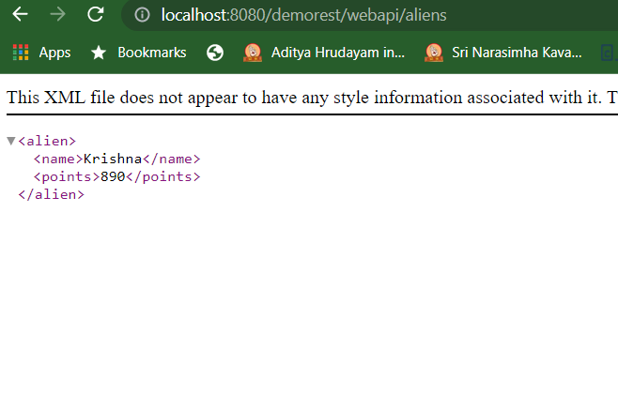

Create a object 🡪Create a method-🡪get the object -🡪return the resource

And if suppose if we want to return from database ,we can do it simply from using the Hibernate

Next item is now we are able to return only one alien ,instead suppose lets say I want to return multiple aliens …how can we do it

Step 1:

Pass the Alien1 and Alien2 to a list and return as list

change the method signature

Below is the code snippet sample

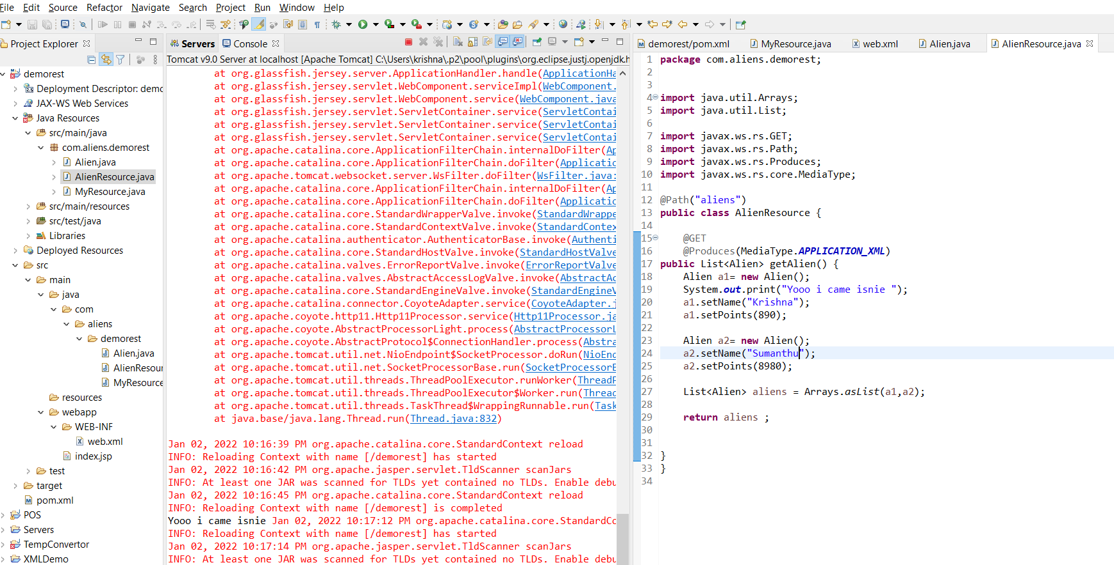

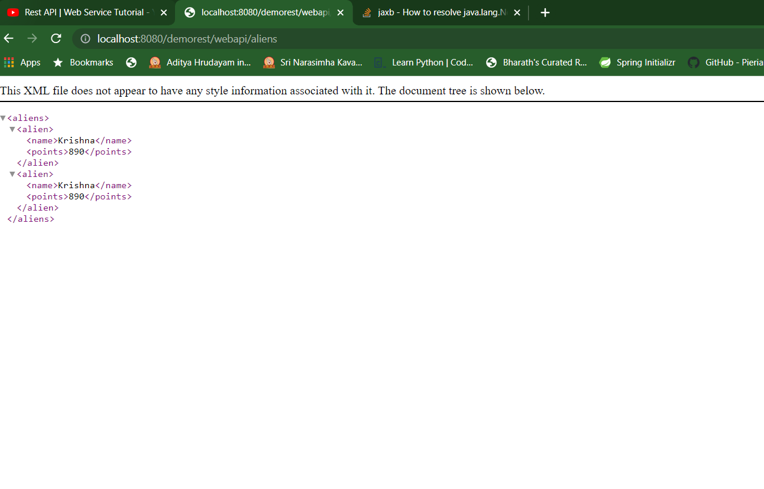

So now we are able to fetch all aliens

As of now we are creating our own resources ,but generally all the data comes from the database

We shall see all those in future

We need to create a separate class where we can connect with database ,fetch the data from database etc…

Instead just for testing purpose we can even mock the data for now

Normally the class which deals the database is called as **DAO** but in RestApi we call it as Repository

That’s just a basic difference

This class works with database

We can fetch /update /add /delete alien with Alien repository

So first lets mock up some data in the AlienRepositoryClass …

We remove all the data from Alienreosurce class to the Repository class as shown below

**package** com.aliens.demorest;

**import** java.util.ArrayList;

**import** java.util.Arrays;

**import** java.util.List;

**public** **class** AlienRepository {

List<Alien> aliens ;

**public** AlienRepository() {

aliens=**new** ArrayList<>();

Alien a1= **new** Alien();

System.***out***.print("Yooo i came isnie ");

a1.setName("Krishna");

a1.setPoints(890);

Alien a2= **new** Alien();

a2.setName("Sumanthu");

a2.setPoints(8980);

aliens.add(a1);

aliens.add(a2);

}

**public** List<Alien> getAliens() {

**return** aliens;

}

}

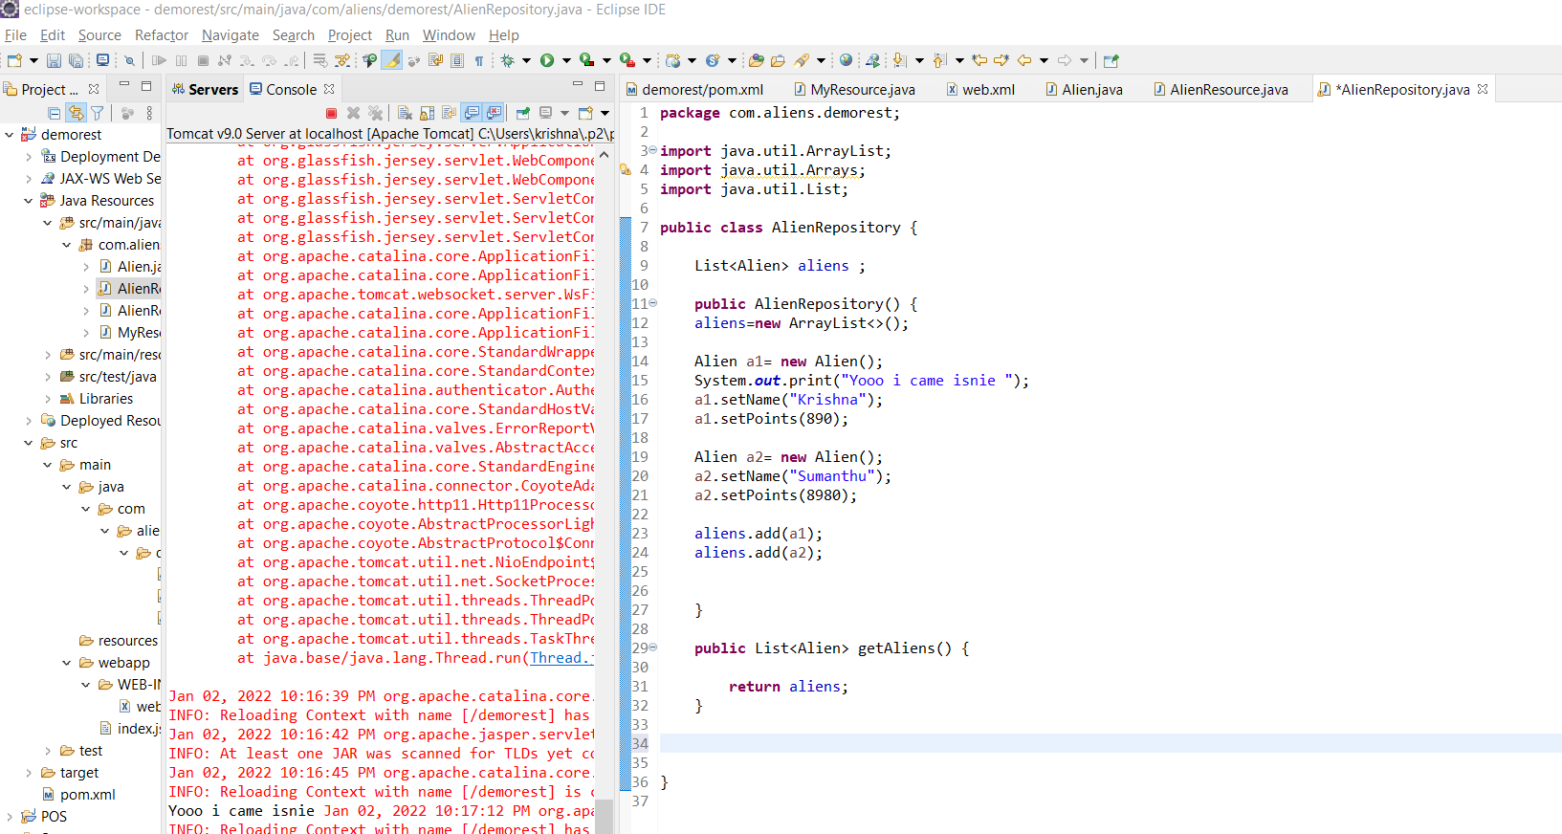

And now some more customization after this…

We can customize to fetch only a particular alien by passing the points passed

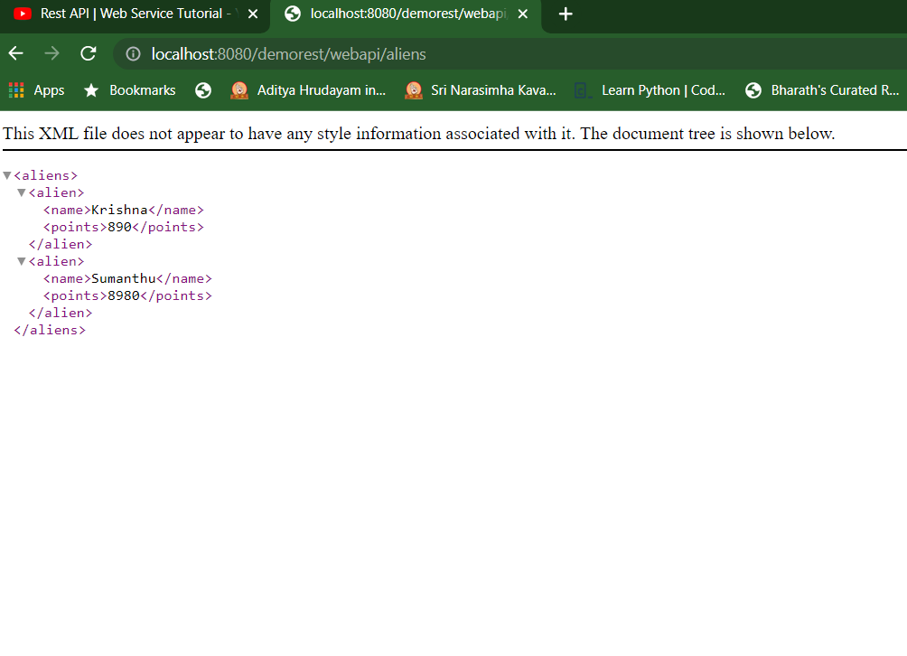

Now lets try how to insert into the database…For that we need a method ofcourse

So we will write a new create method in our resource class

Whenever we are creating a new resource in the database we will be using the @POST annotation

And also we weed to change the url for the same maybe like aliens/alien so for that we give the path as well

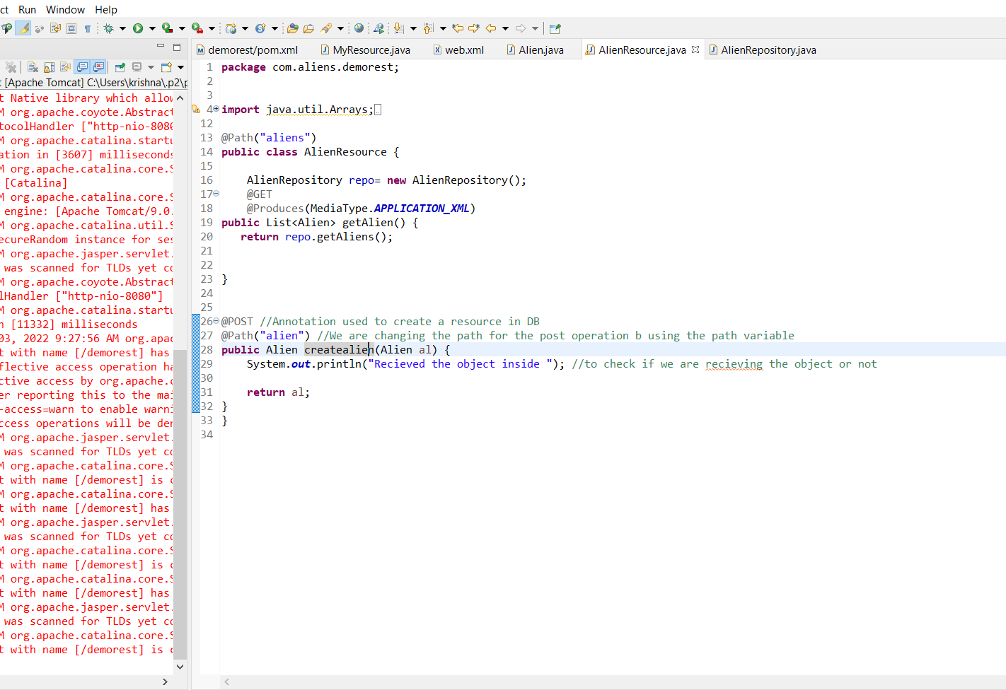

Now we also need to have a method which helps us to store the data in the DB

For that in repository class we will create a new method

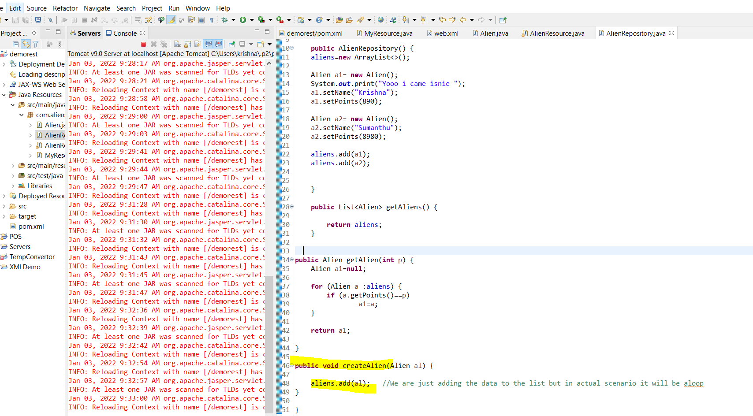

And now we invoke the same method from the AlienRsource class

If we are fetching the resource, we would directly call the method and see the data

But now we want to insert the data …and now we are not building any website or we don’t have any form as well …normally sending and fetching data we have client application like a mobile app is the client /Angular/ JS is a client

so how can we pass the data is the next question we have?

Now we don’t have any as such so we can use some tools for example **POSTMAN**

POSTMAN acts as RestClient

But why we need separate app is we will able to send multiple request where in brower we can only do GET and POST only

We can even create a Java Client also but we have a ready made tool like postman we can use this

We can also fetch the data in JSON format /XML format as how we need using the Postman

Go to chrome🡪webstore🡪

If u search for RestClient you would get many options …search for postman we can see the app not the extension ,click on add to chrome /we can also download it directly

Below is how we use it

GET Request Demo:

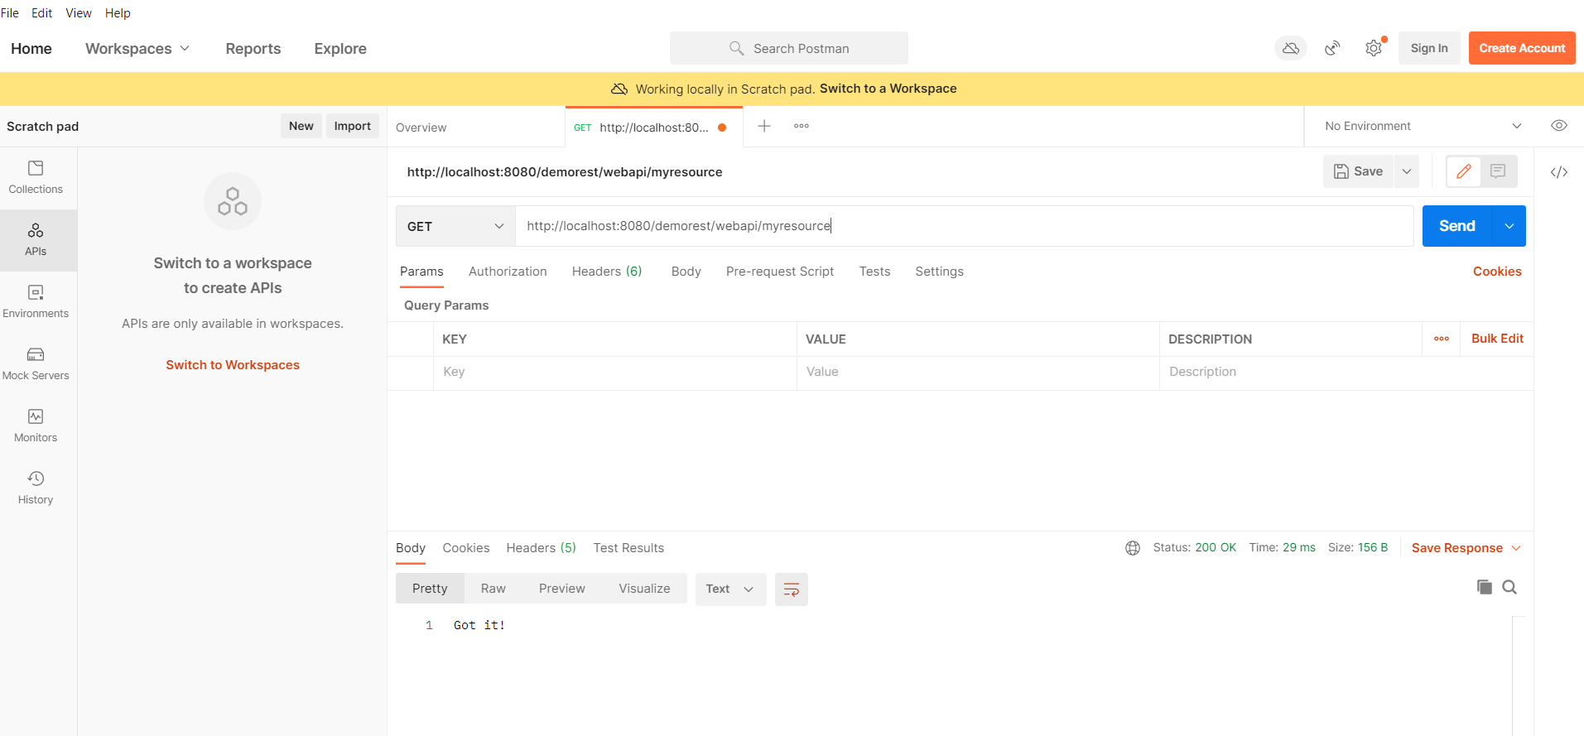

And now incase of POST request how will we do ?

**Send a POST request using the POSTMAN**

As we remember we wrote @XML root element which means we are expecting the xml resource for performing the post operation In Postman change the operation from GET to POST ,change the url also

And give the data we want to post in the Body section

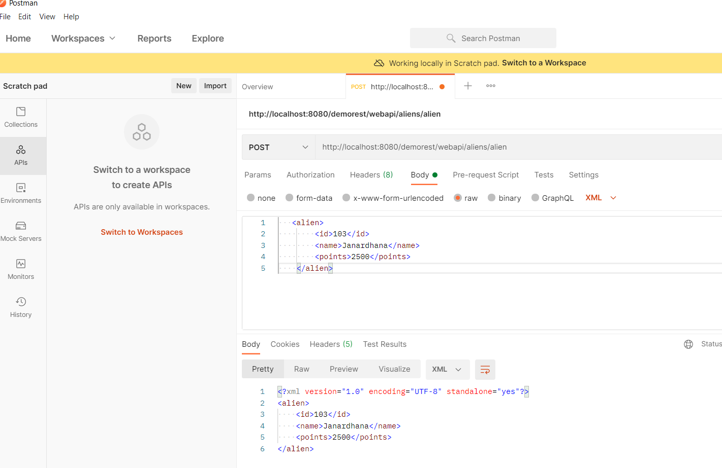

**Note :I have added ID field agaian made some code changes for conveince purpose**

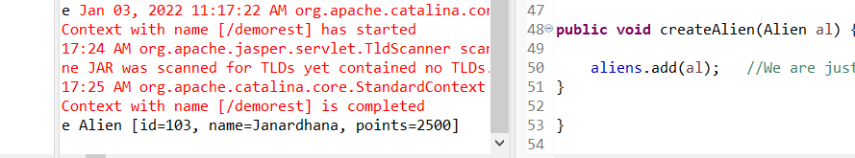

**And yes I am receiving my data from client**

**We can write JDBC client code here and save the data to the database**

Suppose lets say I want to retrive a specific alien wrt to id which I will pass

At first we will try hardcoding for a specific alien

And also we will be changing the path which can seen below

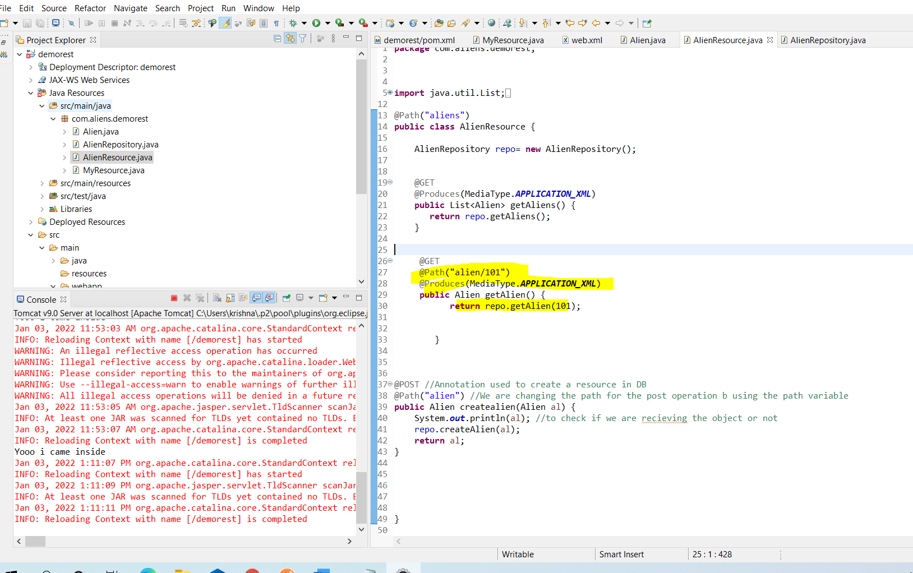

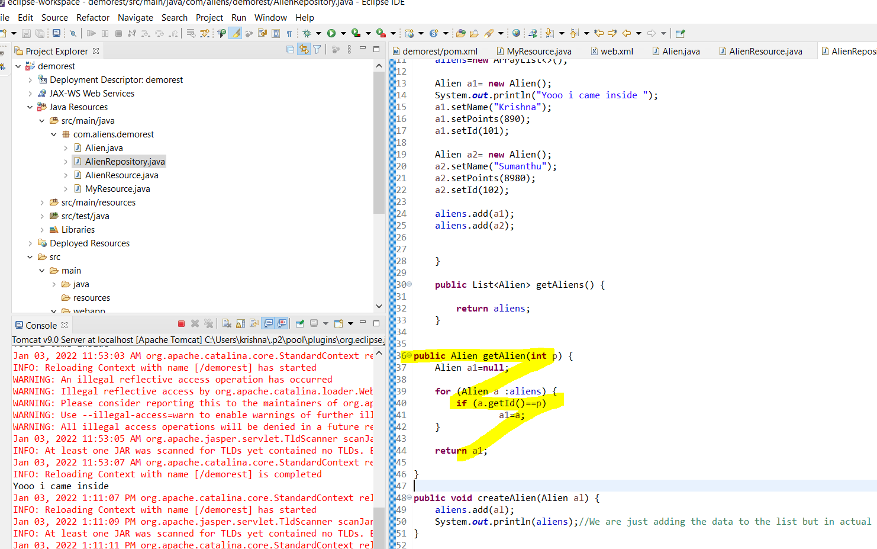

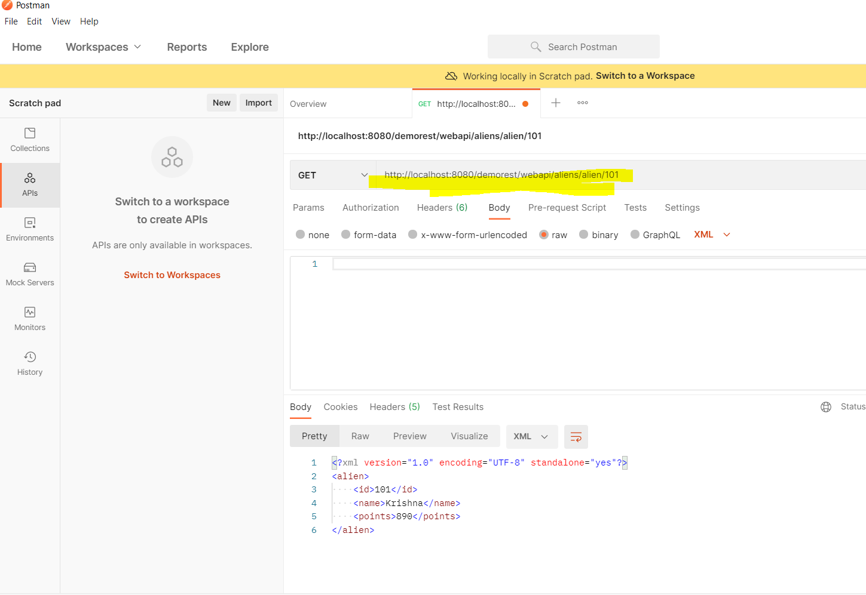

So above we can see we got the output when we passed 101

Suppose lets say now we pass as 102 we will get the error as below

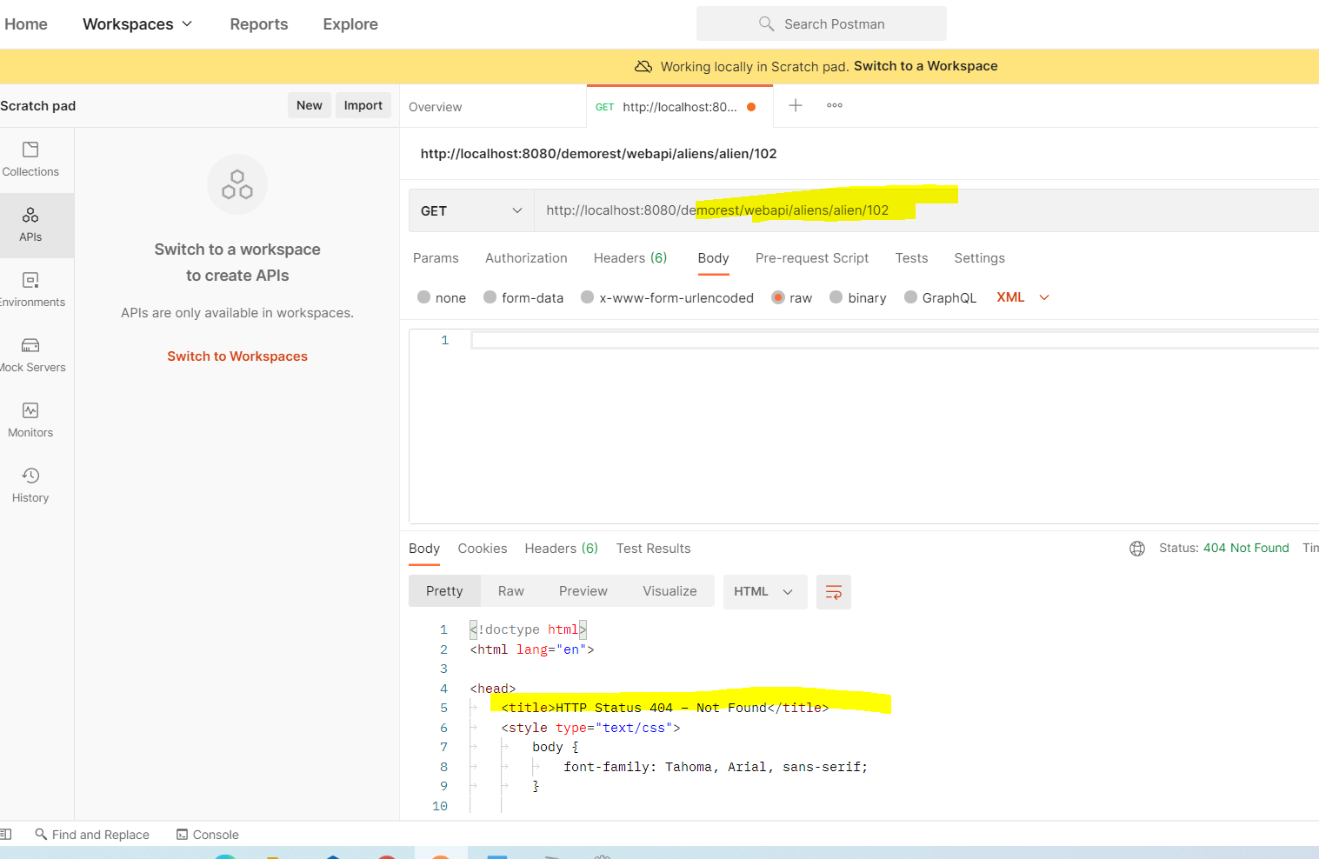

We are receiving the 404 error .Now we cant write one more method as it’s a wring way of coding

So what else …we shall parametrize the ID ,how can we do that is just add curly braces

Curly braces we represent that id with anything we want

But how to store that value and pass it to the function…?How to fetch the value and pass it

For this we will be use the Annotation @PathParam

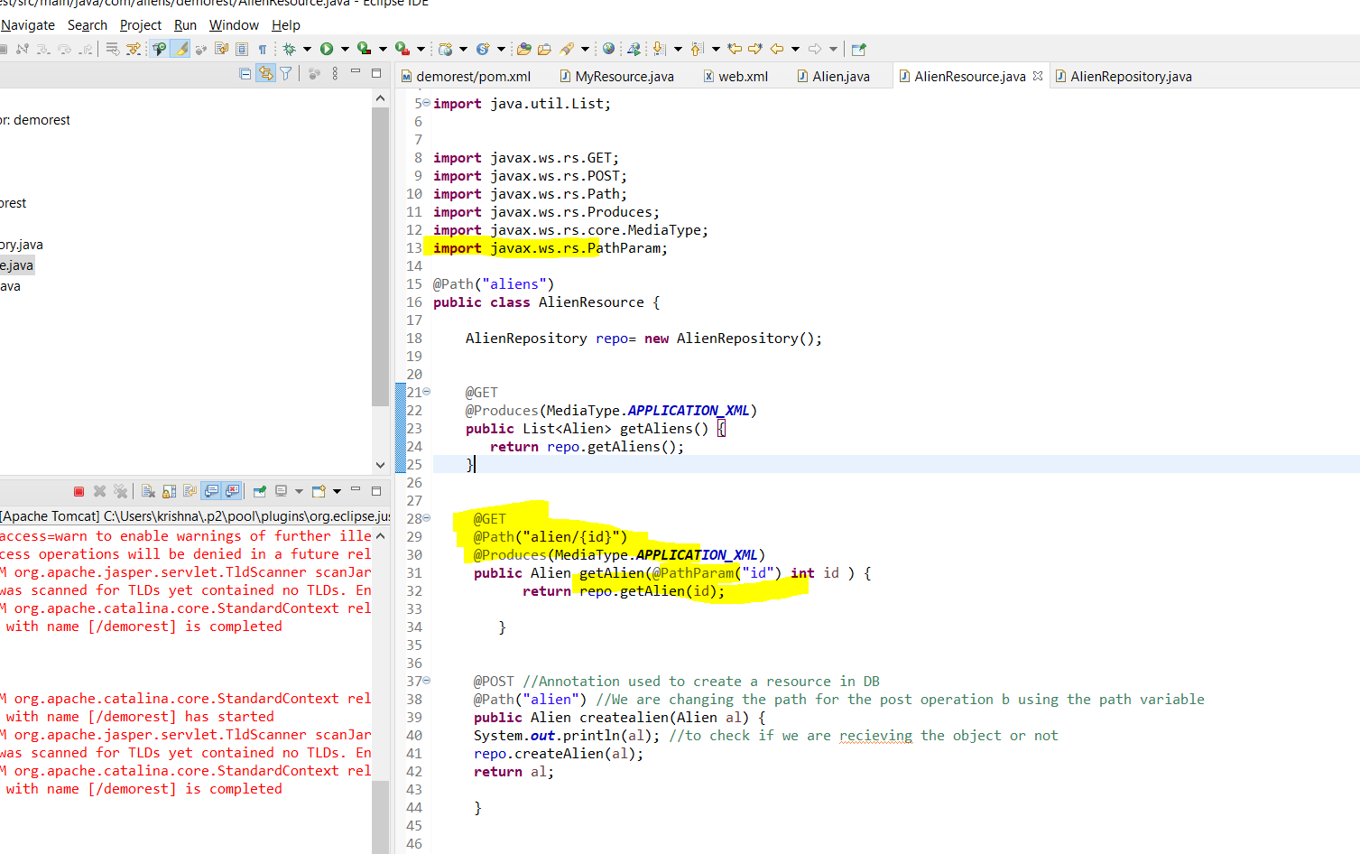

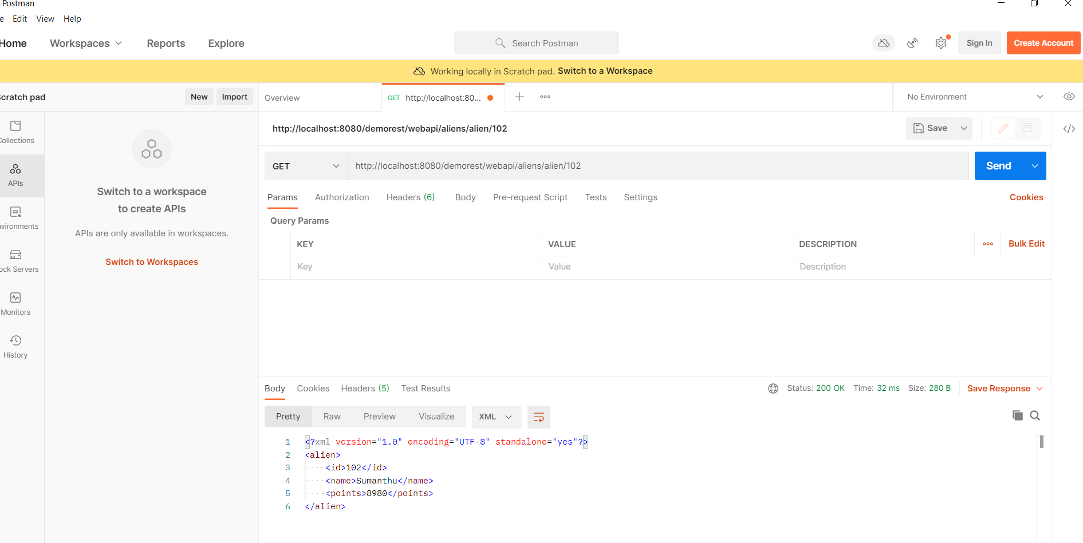

Can we configure the server in such a way where we can reciver either JSON/XML depending upon the client request

We want client and server to go for content negotiation It means what ever format client asks for Server gives in that format

How to return JSOn format?

Its very simple…

@Produces annotation takes array of datatype

We shall modify here .First lets remove the XML format and just give the JSOn format

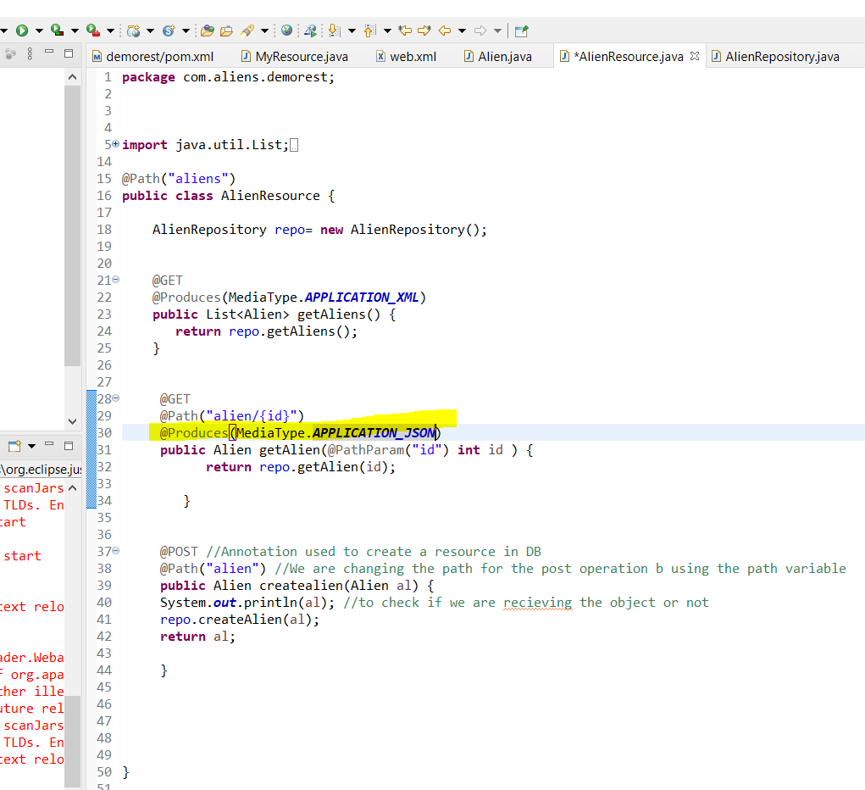

Now send a request from postman as below we get a server error

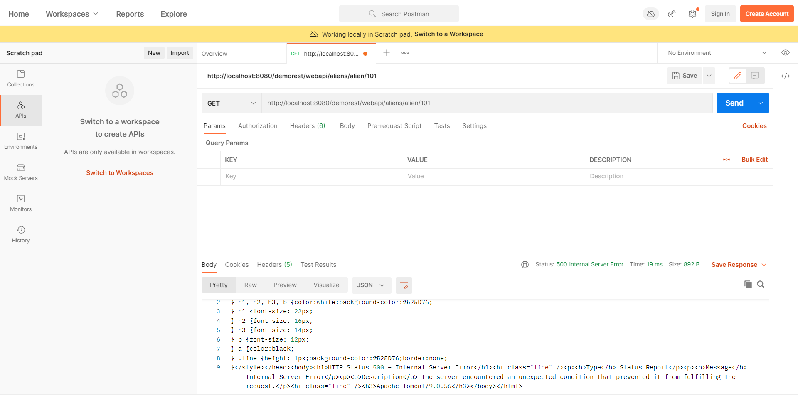

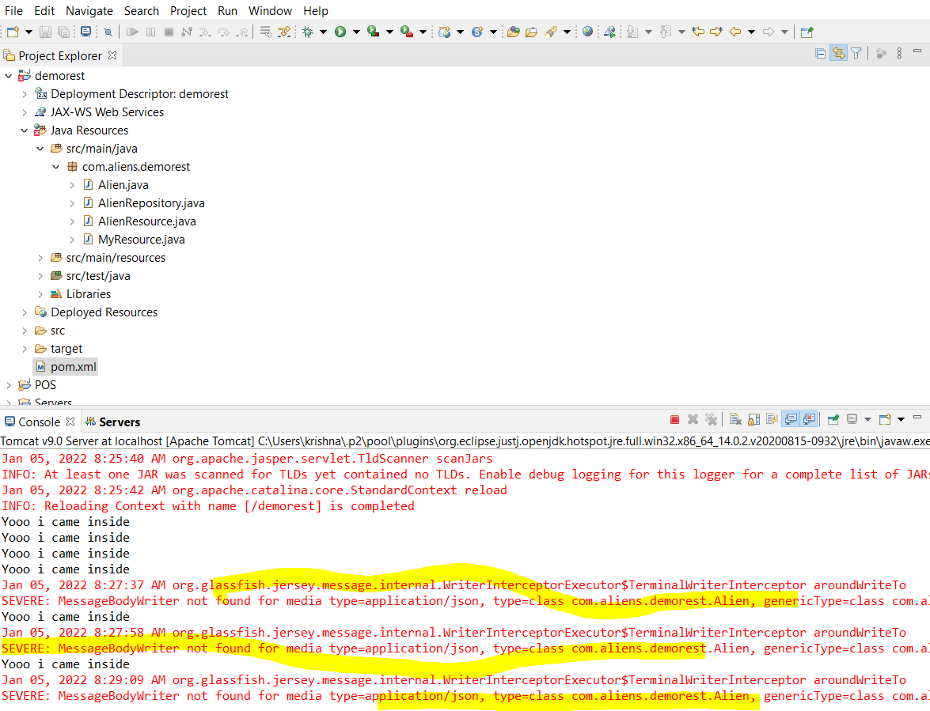

Above is the server error

The reason why we are getting error is because Jersey normally works in XML which is default

If we want to use JSOn we need to use external dependencies

By default a commented code is available in POM.xml

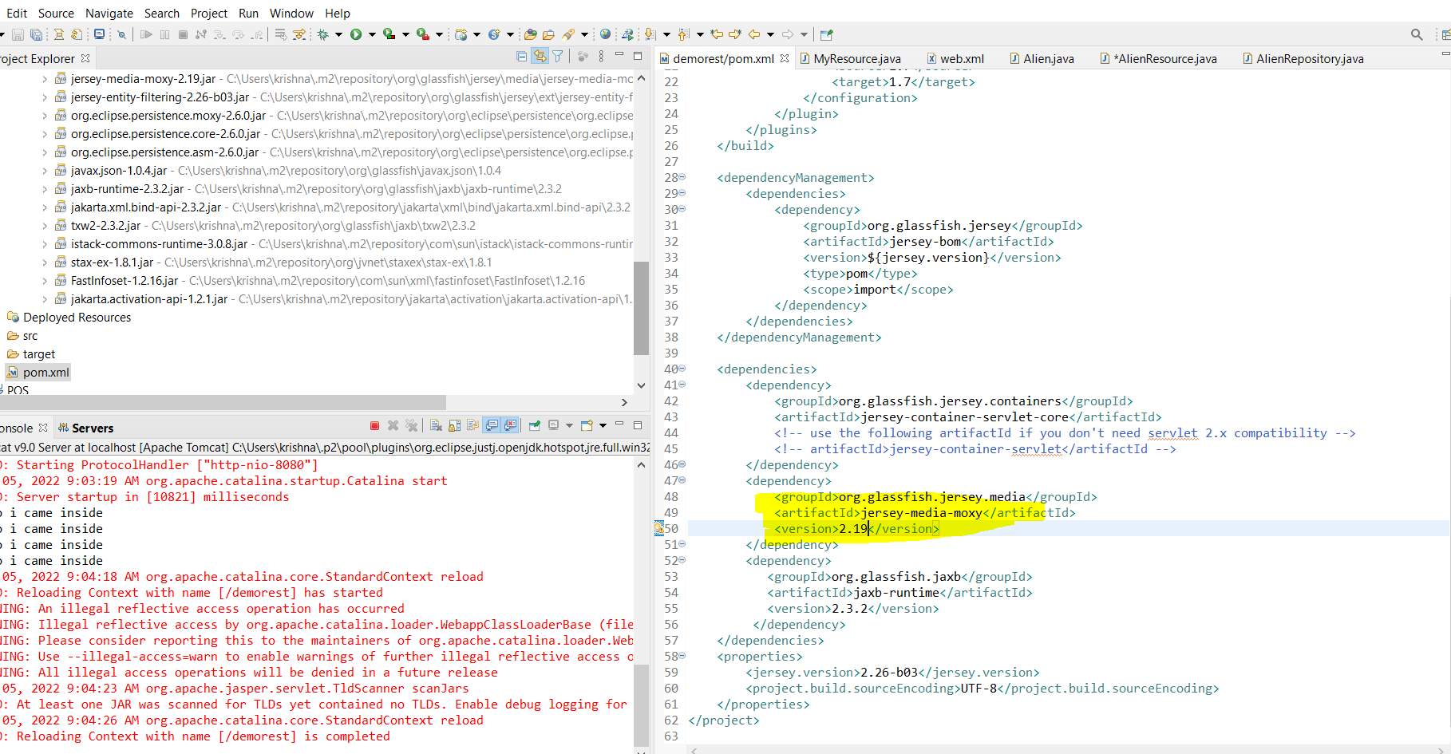

Above highlighted code is uncommented and give the version as 2.19 .(here sometimes u might face few issue that time try changing the dependencies )

Now how do we send a request from postman to get the JSON response is below

Accept **indicates what kind of response from the server the client can accept**. Content-type always is about the content of the current request or response. ... Accept header is used by HTTP clients to tell the server which type of content they expect/prefer as response.0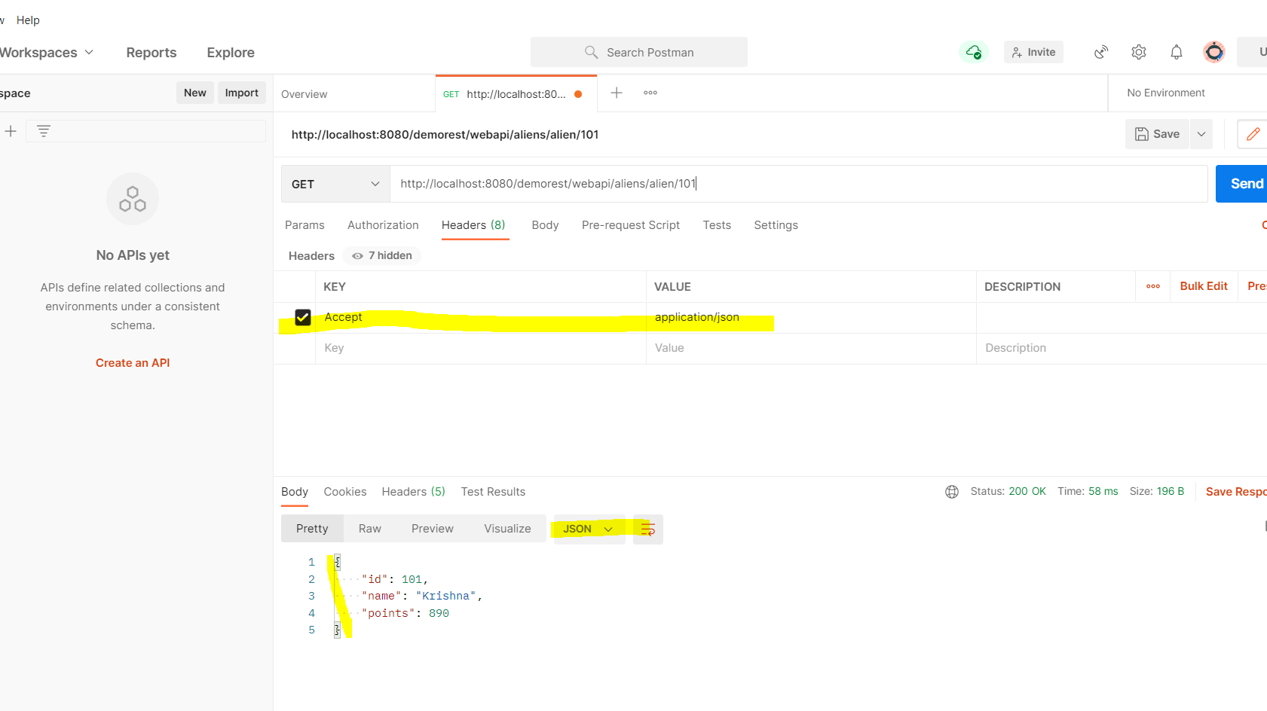

So now we are able to recive the JSON response happily

Now what if client wants XML back again,how can we do with same code ?

IF we try now only we get the 406 error because we changed the config fromXML to JSON

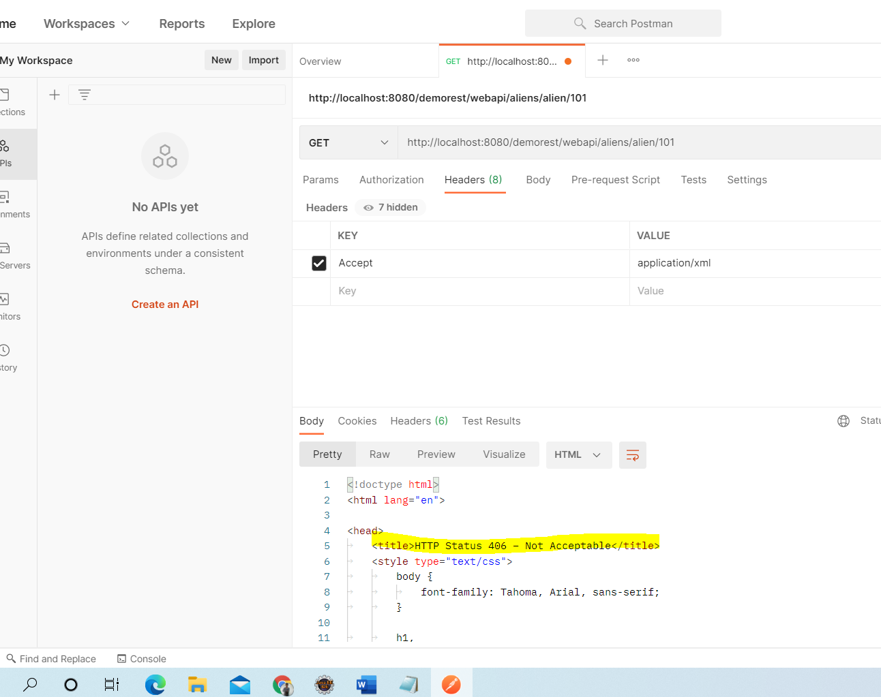

Yes just give the return type in array

Then depending on the request automatically jersey will return the response

Below is the code change

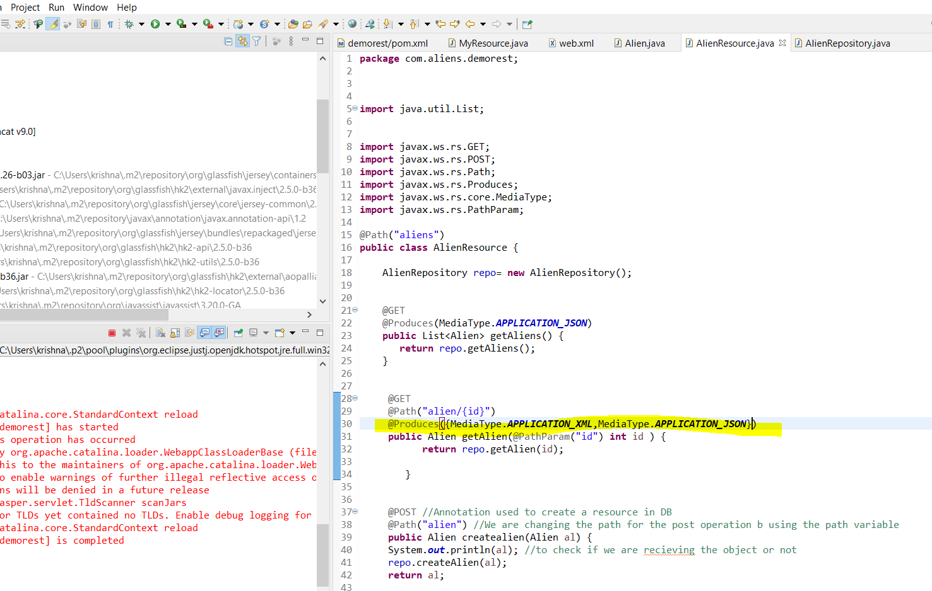

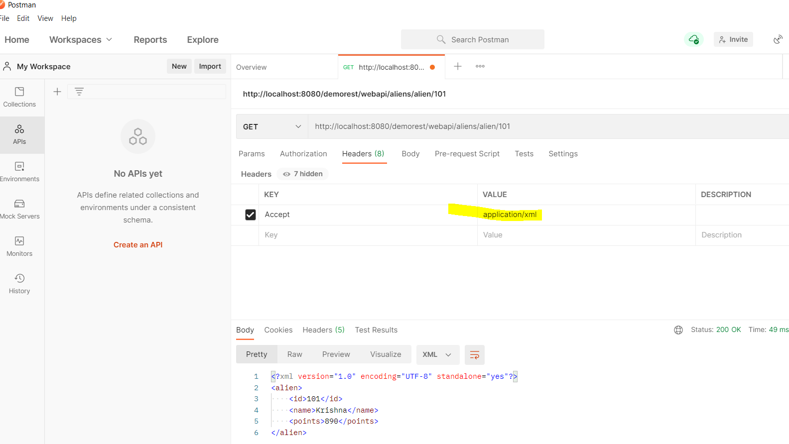

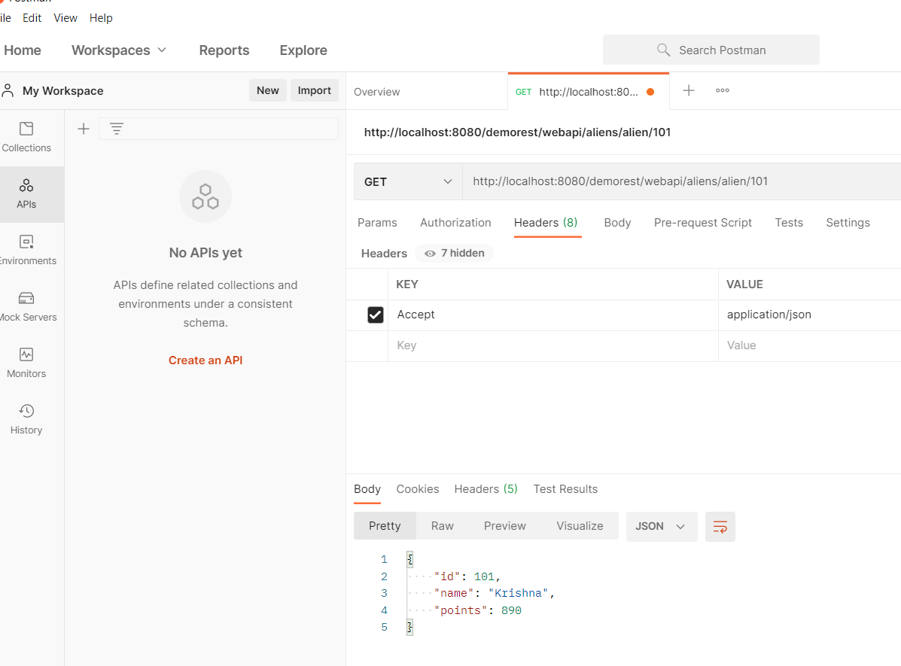

And now are able to fetch data both in JSON and XML

Till now we are using a kind of mock repository .But in realtime we have a real database repository

So then

Which DBMS we are going to work on?

Which framework we are going to us e?

Lets use SQL (by Microsoft ) for now

MYSQL is by oracle

Framework we can use hibernate but instead we can do with simple JDBC connection .No connection pool and all for now

How to implement JDBC connection?

1.Import the package

2.Load and register the driver

3.Establish the connection

4.Create the statement

5.Execute the query

6.Process the result

7.Close the connection

So import java.sql.*

Then we need SQL connector ..so got to maven repo 🡪serach for my sql connector 🡪

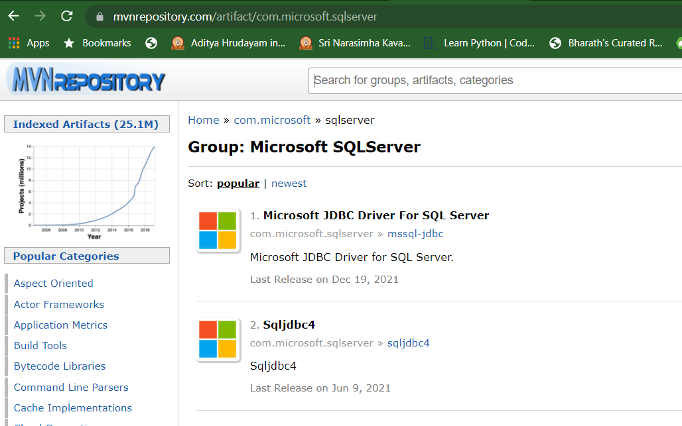

Use the mssql-jdbc-8.4.1.jre8.jar file when you compile your code with JDK 8.

Add the Maven dependency in our pom.xml

<dependency>

<groupId>com.microsoft.sqlserver</groupId>

<artifactId>mssql-jdbc</artifactId>

<version>8.4.1.jre8</version>

</dependency>

Modify the Repository class as shown below in such a way it will connect to the SQL server

In order to load the SQL connection…

String url = "jdbc:sqlserver://DESKTOP-237OF0F;Database=RESTAPI;username=sa;password=krishna";

**try** {

Class.*forName*("com.microsoft.sqlserver.jdbc.SQLServerDriver");

con = DriverManager.*getConnection*(url);

System.***out***.println(con);

} **catch** (Exception e) {

System.***out***.println(e);

}

}

Here with url we will connect to SQL server with proper name

Class.forname ---basically it helps us by returning the class instance

returns the Class object associated with the class or interface with the given string name, using the given class loader

Now we will get connection finally and using it we will be able to execute various methods

Then in order to fetch all the aliens from the DB we will be using below method

We write below method in repository class

AlienRepository :

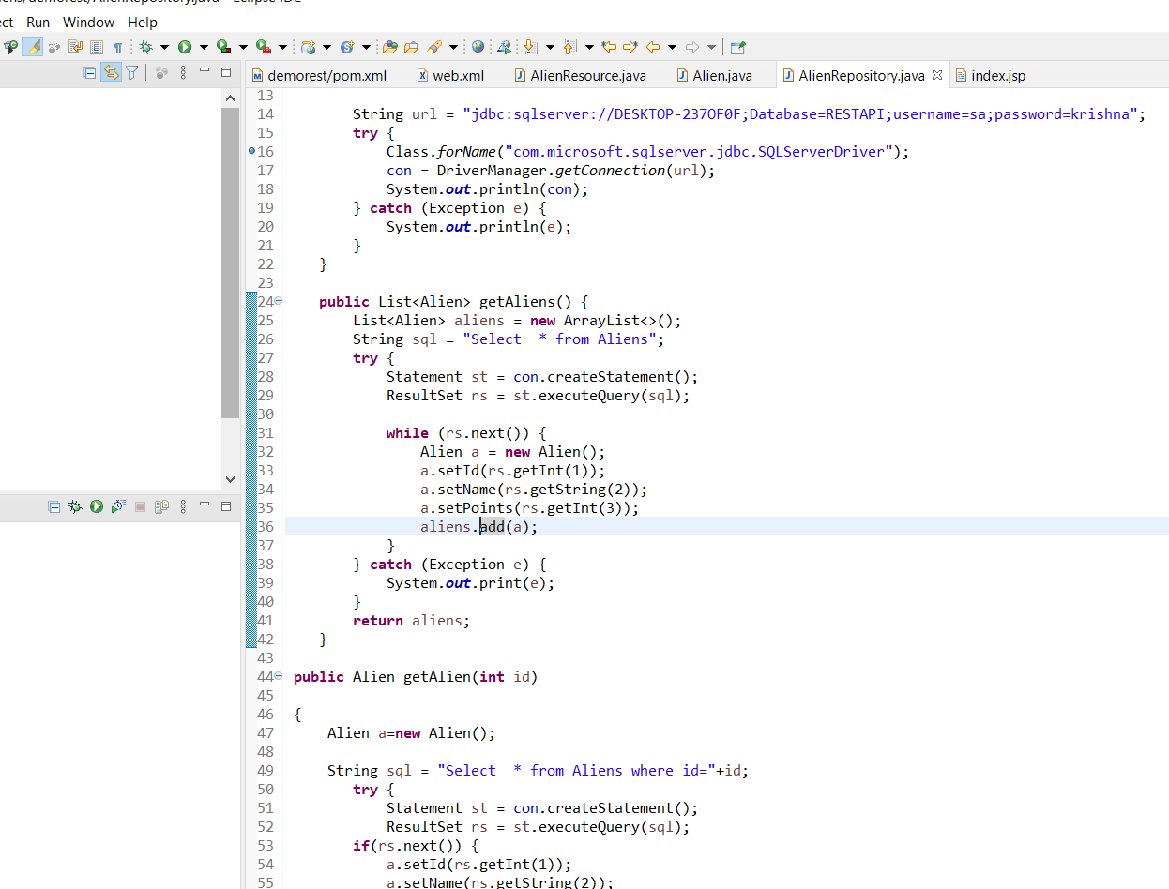

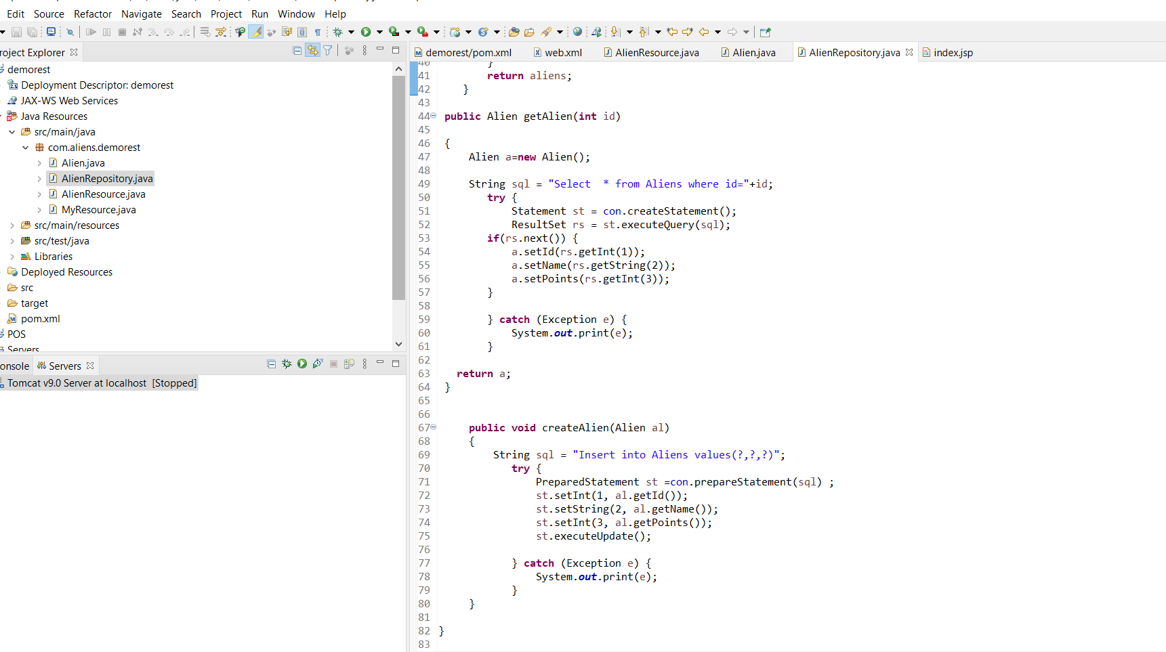

Now we also need to change the methods in the Resosurce

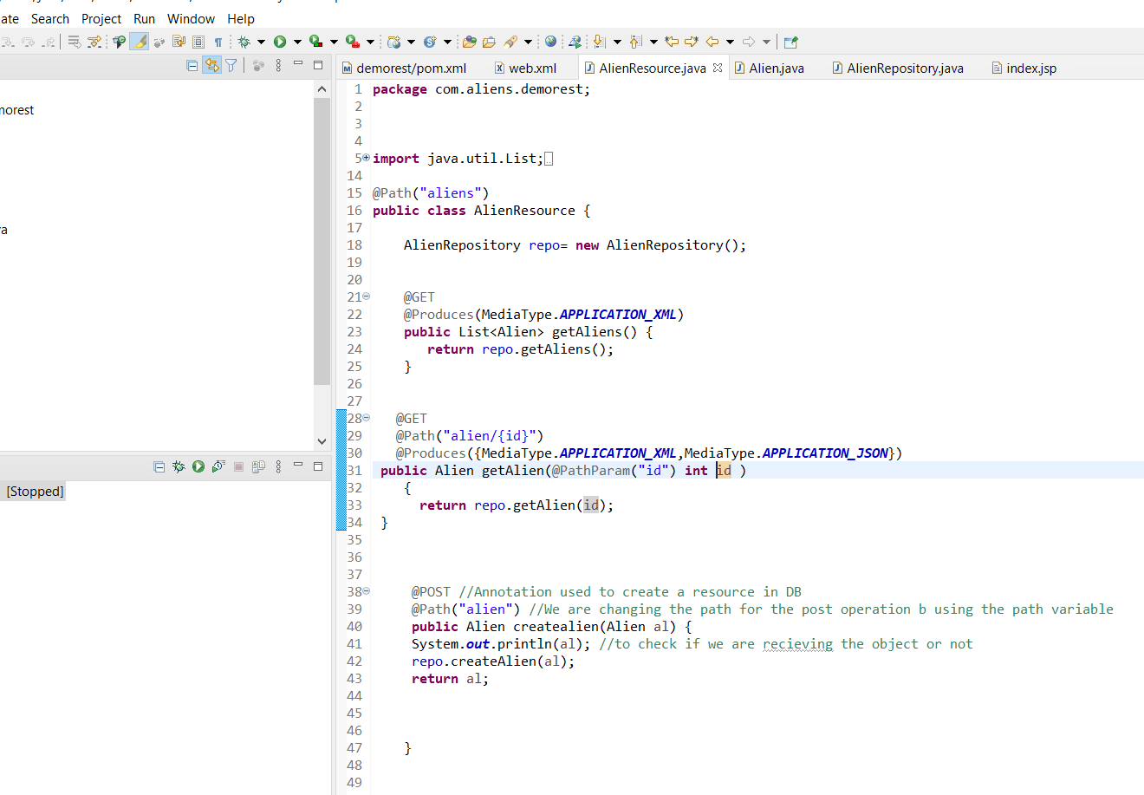

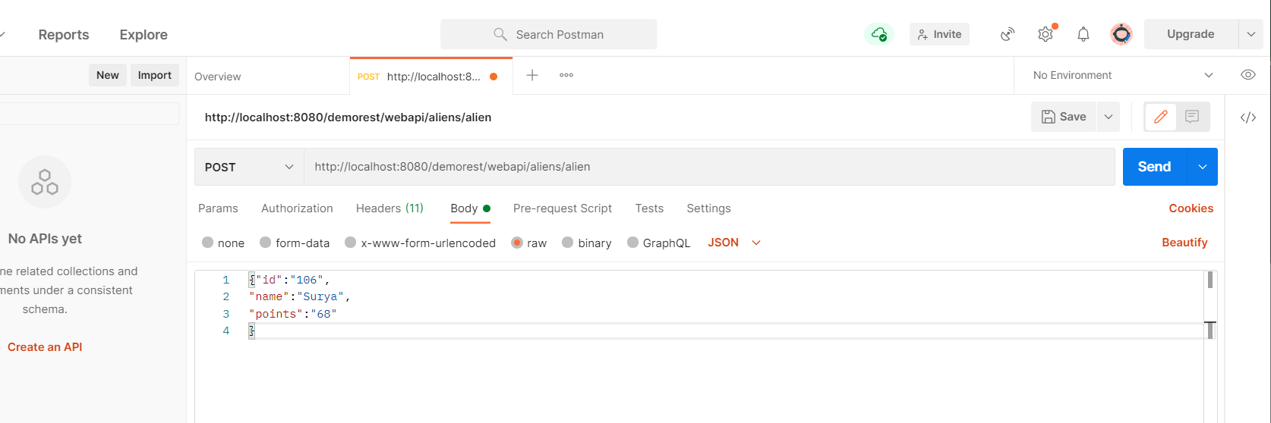

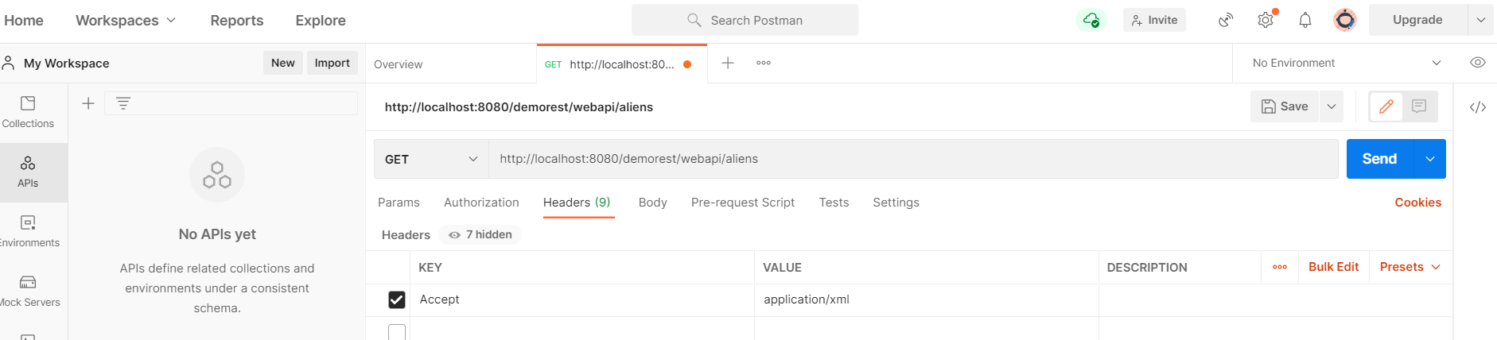

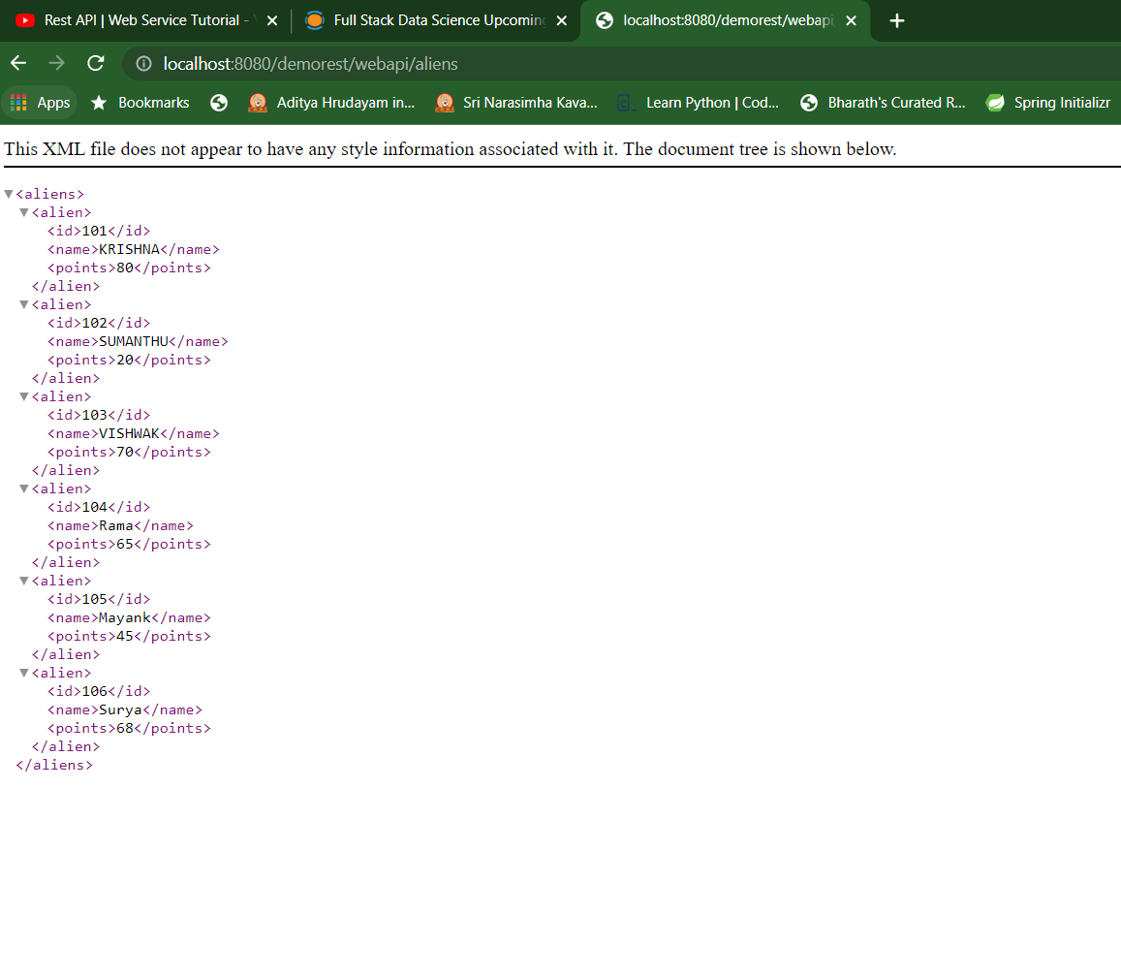

In this way we will be able to fetch and store the data in the database

We basically made our application now give response as either XML/JSON

Similarly we can also control our application in taking the input also. This can be done by using @consumes annotation

Code can be changed as below in the Alien Resource class

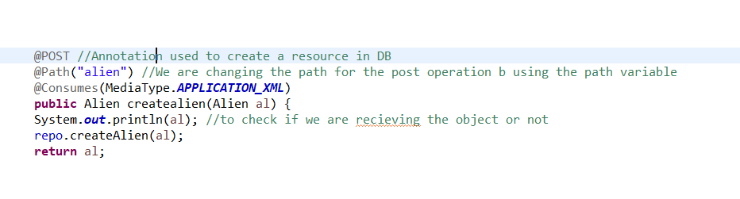

Now try to give the input as JSOn from postman it will throw the error as below .We can take a look

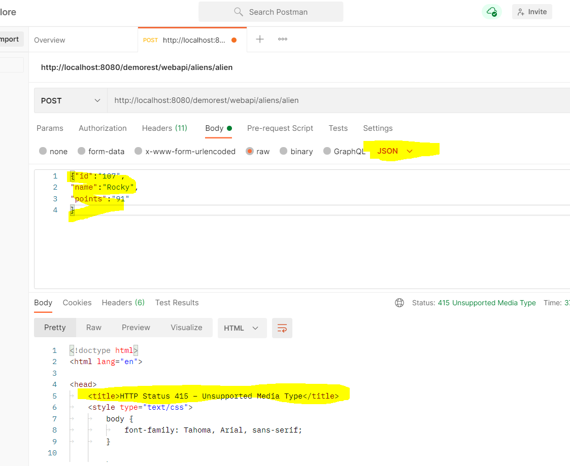

But suppose lets say we don’t specify the data type it will work for both JSON and XML

If in case we want to specify the same in code we can give it as array in @ConsumeAnnotation

So that if in case client sends some invalid data it throws the error

Handling of the Put Request :

PUT helps us to update the values

Post is the one which helps us to create the resource

So now in resource class we write a new method and also a new method in the repository class to update the data in the database

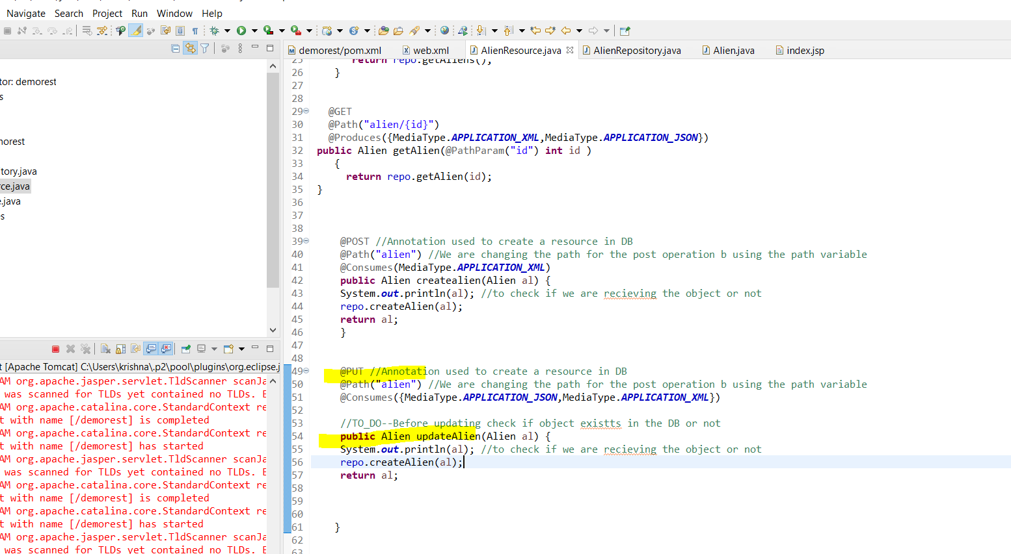

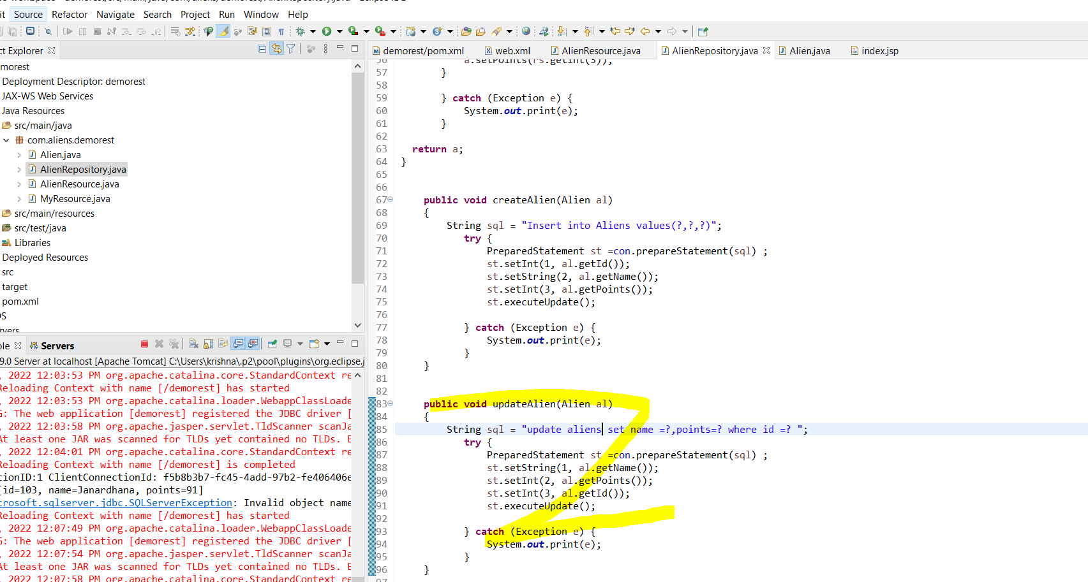

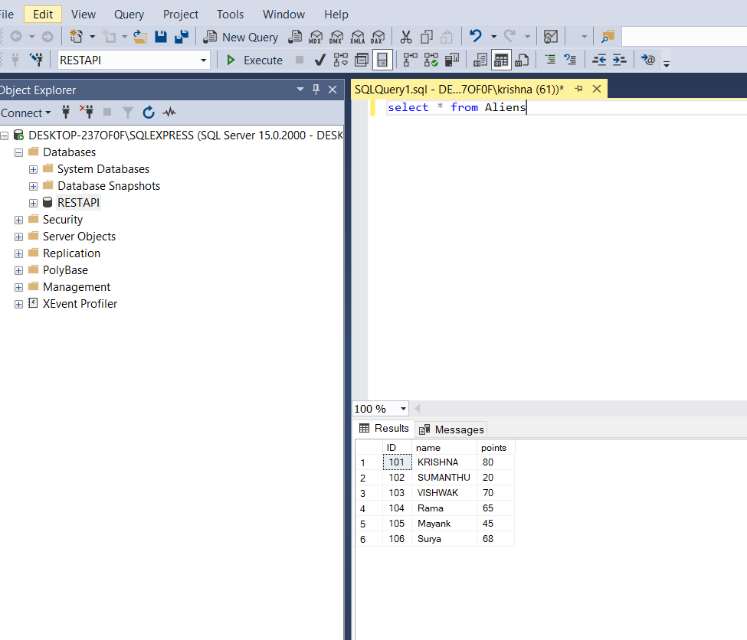

Lets run a PUT request to update the ID=103 to Janardhana

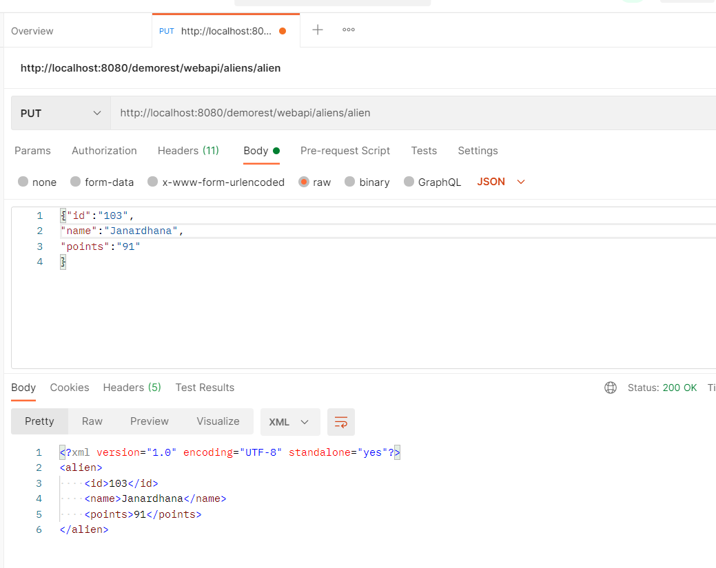

Now run the query in the dtbase

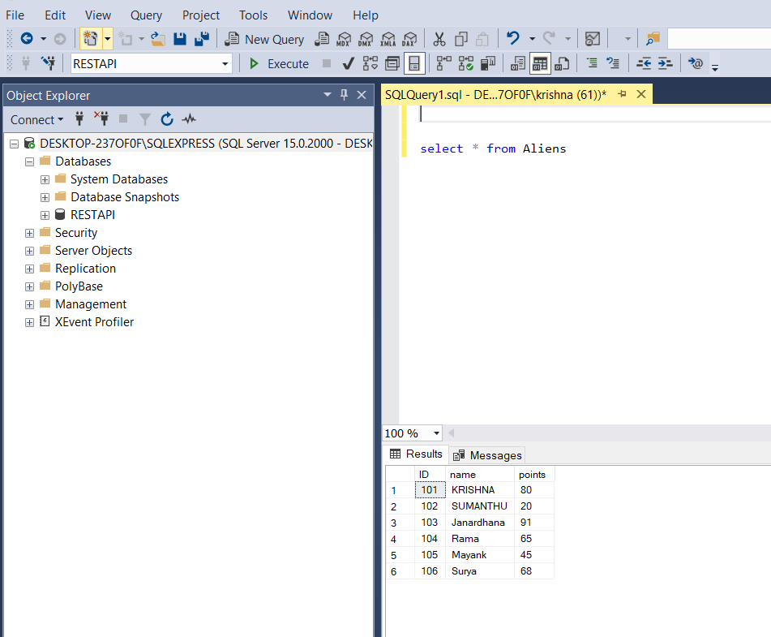

Now suppose if you try to update with an ID which does not exist in the database….then it does not effect in anyway for now

For this either we can throw an error to client saying resource does not exist or basically try creating a new resource

We need to make code change as below

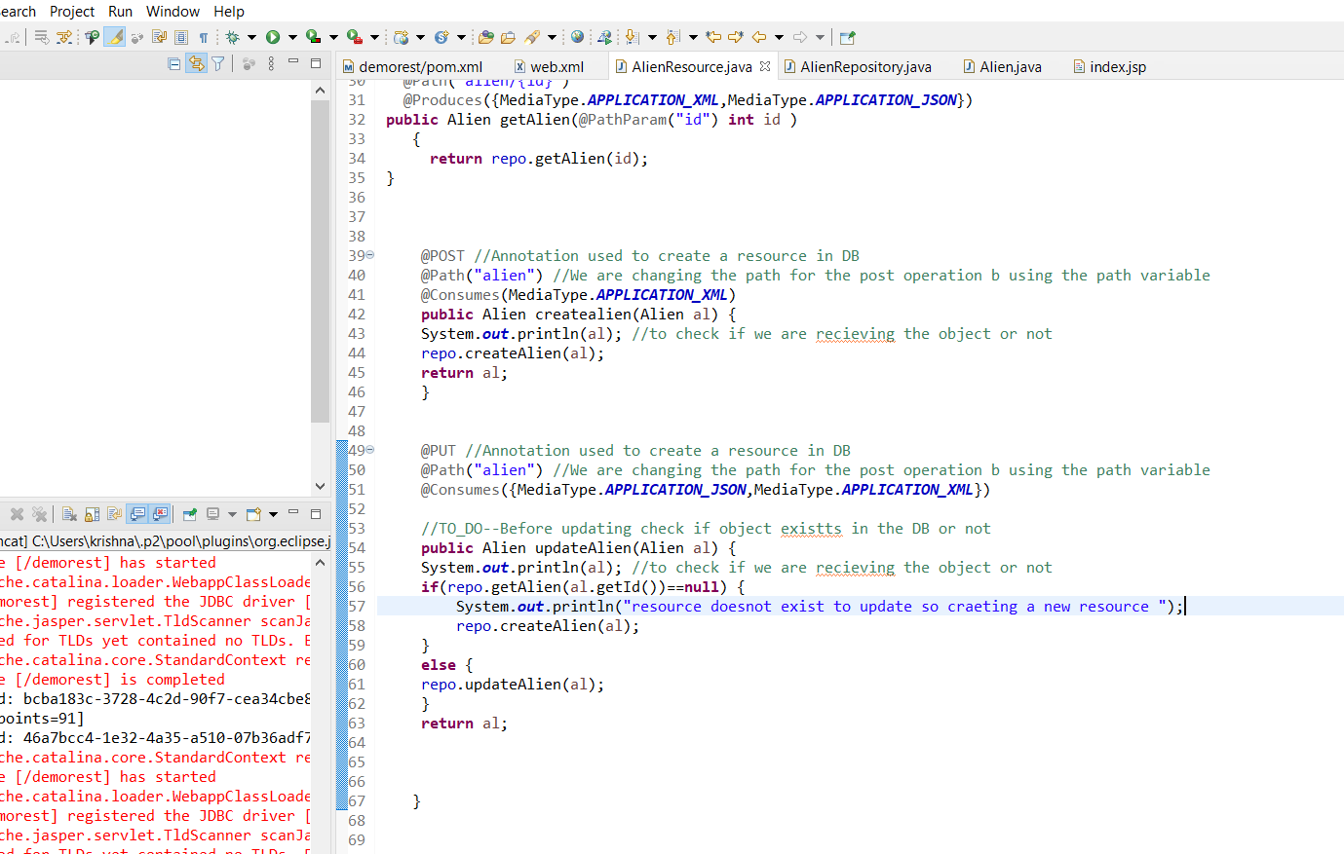

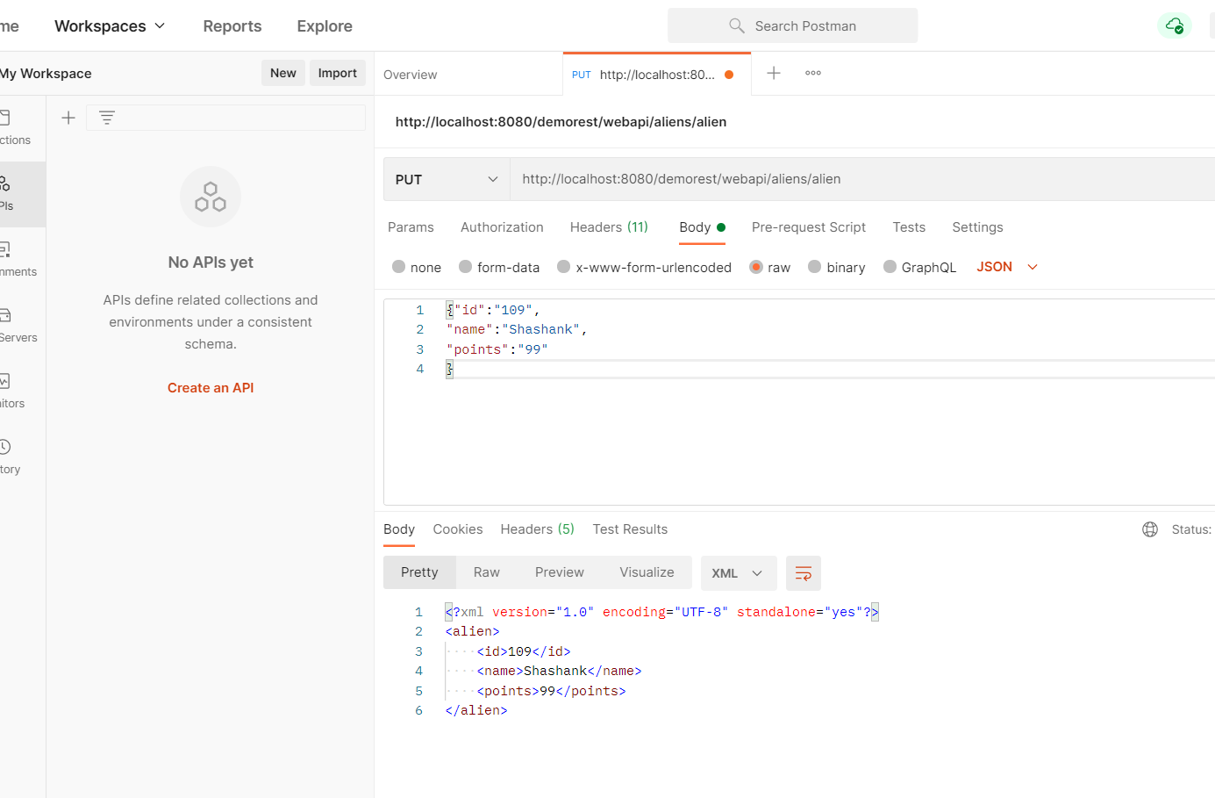

But there is a small glitch in the code which after debugging I got to know as below

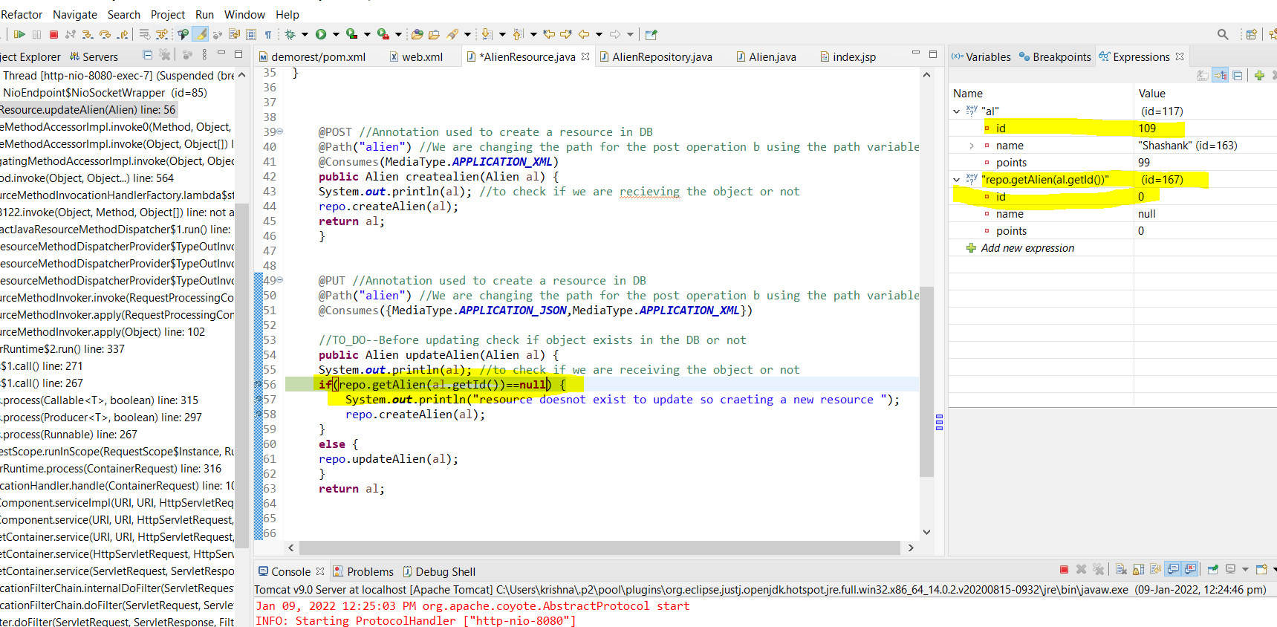

By using the Debugger tool we are able to see that the value is zero in the ID but not null

So lets change line a little

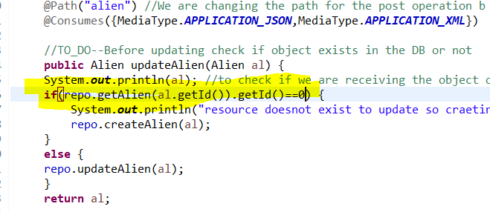

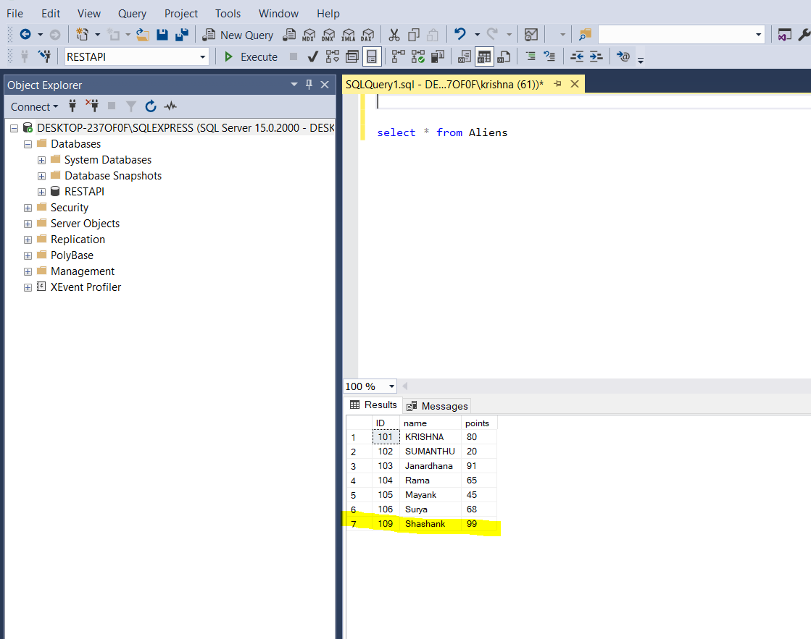

Delete :

We can use all the HTTP methods to do all kind of operations

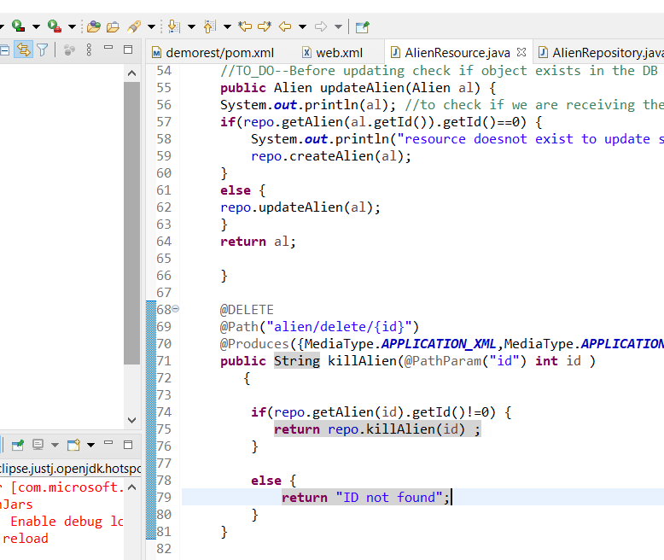

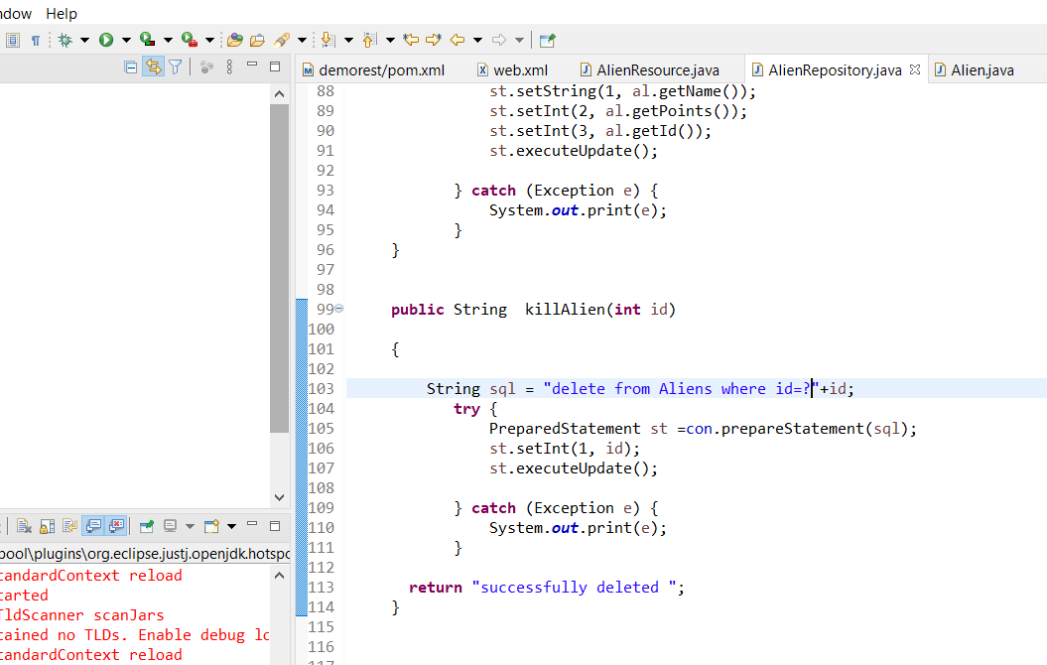

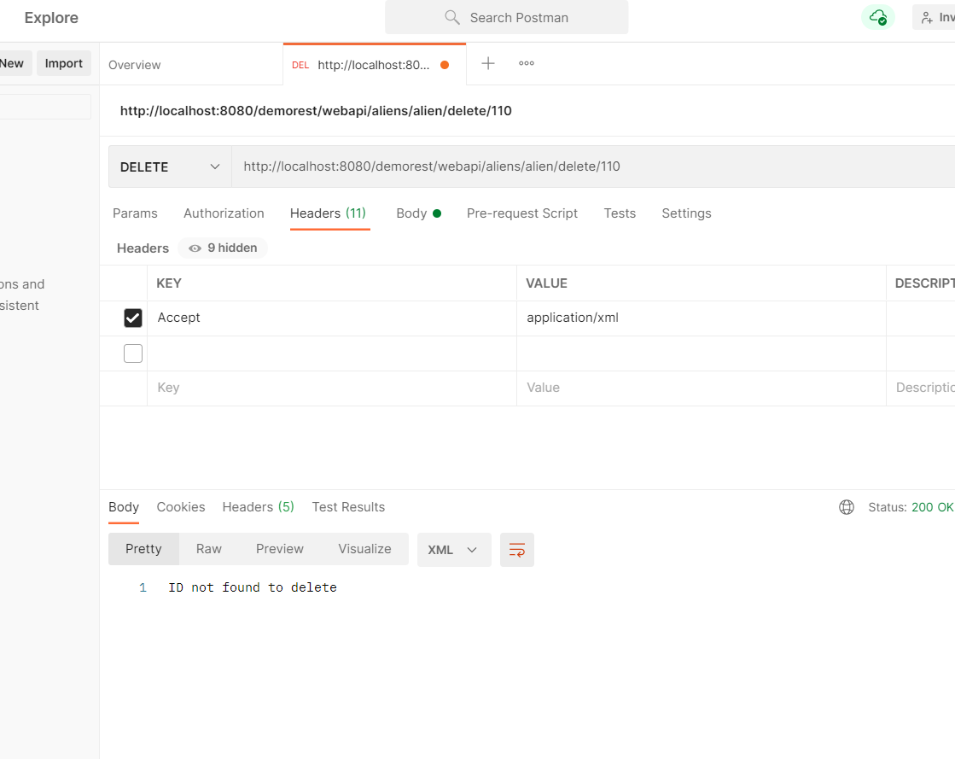

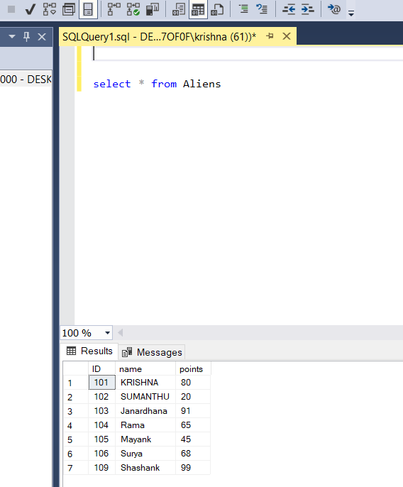

Now one more operation….

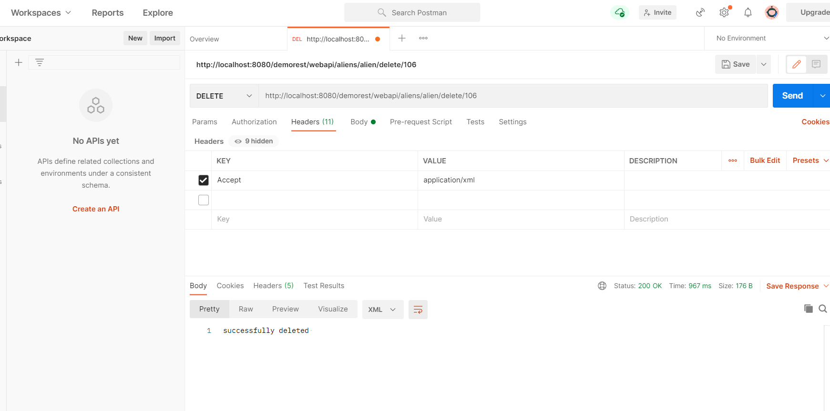

So finally we covered all the HTTP methods..using the Jersey Java and Postman

1.GET -fetch the data/resource as needed

2.POST -Create a new resource

3.PUT-Update the resource

4.Delete -To delete the resource

As of now we used Jersey …

But one more is Spring Rest Framework which is latest and used by few organizations as well as we also have Spring Core(object creation ,passing, dependency injection ) ,Spring MVC(framework to build website with servlet and JSP ),Spring ORM(connect spring and ORM),Springboot(make software dev experience easy ---all things become very easy),Spring Security

Note :

1.Java fundamentals (collection API, exception handling )--🡪Spring Core (Dependency injection)-🡪If we want to make a website then understand the Servlet then JSP which are defacto .Servlet is something we always use .Tomcat supports only servlet ---🡪 Then Spring MVC -🡪Get a feel of RESTAPI(Rest on Jersey)🡪Spring Rest -🡪

Spring MVC🡪Hibernate (A replacement for JDBC connection)-🡪Spring ORM

2. https://www.youtube.com/watch?v=JuFdz8f-cT4